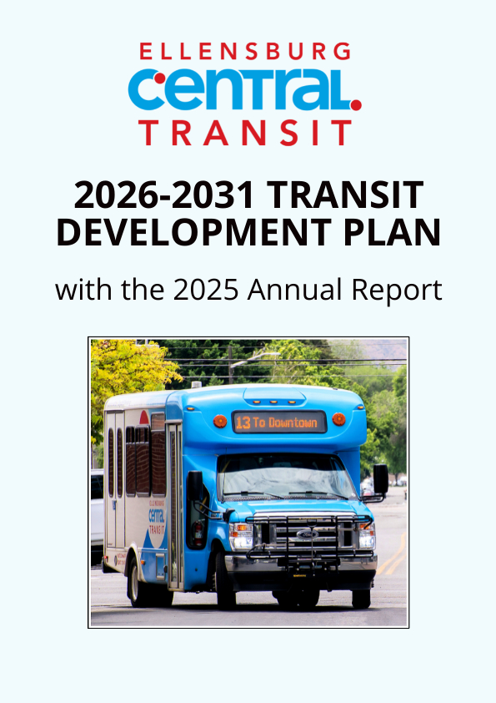
Ellensburg Central Transit
501 N Anderson St., Ellensburg, WA 98926



TABLE OF CONTENTS

Introduction…………………………………………………………………………………………………………………..…….3-4
Mission and Strategic Priorities …………………………………………………………………………….….……….4
The Agency.…………………………………………………………………………………………………….…..…………….…. 5-7
Governing Body……………………………………………………………………………………………………………….6
Organization....…….………………….……………………………………………………………….…………………….6
Agency Structure …………….……………………………………………………………………….……………..….… 7
Services………………………………….………………………………….…………………………………………………..……8-10
Fixed Route…………..……………………………………………………….………………………………………….……8
ADA Paratransit …………………………………………………………………………………….………………….…….8
NEMT Cabulance ………………………………………………………………………….…………………………….… 9
City Limits Map .…….……………………………….……………….……………………….….…………….……....….9
Pedestrian and Bike Paths.…………………………………………………………………………………………..…..10
Regional Connections..……………………………………………………………………………………………….…..11
Facilities & Equipment…………………………………………………………………………………….…………….……...11-12
Bus Stops & Shelters..………………………………………………………………………………………………….....11
Transit Hub.……………………………………………………………………………………………………………………11
Contractor Facility & Equipmen.t.………………………………………………………………..……….…………..12
2025 Performance.....…………………………………………………………………………………………………….….…….13
System Performance. ………………………………………………………………………………………………….….13
Projects, Planning & Goals..………………………...…………………………….………………………………….………14-17
Title II……………………………………………………………………………………………………………………………14
ADA Capital Improvements ……………………………………………………………………………………….…….14
2026-2031Planning Service ..…….………….………………………………………….………………….…….…… 15
WSDOT Transportation Goals ..…………………………………………………………………………………………15
ECT Goals .…………………………………………………………………………………………………………………… 16
Fleet …………………………………….…………………………………………………………………….….…………….16
Capital Improvement and Expansion (Required Element) ……………………………………………………. 16
Capital Preservation and Replacement (Required Element…………..……………………………..………. 16
Financial Plan (Required Element) …………………………………………………………………………………...……17-18
Annual Revenues .….…………………………………………………………………………………………….…………17
Operating Expenses …..……………………………………………………………………………………………..…….17
Capital & Operating Improvement Estimated Financial Plan ………………………………………………….18

INTRODUCTION
About the Transit Development Plan (TDP)
In accordance with RCW 35.58.2795, Ellensburg Central Transit (ECT) has prepared and submitted this Transit Development Plan (TDP) for 2026 through 2031. The plan establishes a framework to guide transit services over the next five years, reviews the agency’s accomplishments in 2025, and serves both internal and external purposes. It communicates planning strategies to the public, identifies potential funding sources and grant opportunities, addresses procurement needs, establishes a viable financial plan, and supports updates to the Regional Transportation Planning Organization (RTPO) plan and Washington’s Transportation Improvement Plan.

The TDP aligns with Washington State’s Transportation Policy Goals (RCW 47.04.280). It also supports ECT’s Transit Strategic Plan and economic objectives, as well as the broader regional transportation goals set by the Regional Transportation Planning Organization (RTPO).

A public hearing is scheduled for August 3rd, 2026, at 7 PM at City Hall, located at 501 N Anderson Street, Ellensburg, WA 98926. The public comment period will remain open for two weeks leading up to the hearing. Comments may be provided in person or virtually during the public testimony portion or submitted in writing via email to the city’s transit manager at transit@ci.ellensburgwa.us.

Reasonable accommodations will be provided in accordance with the Americans with Disabilities Act (ADA) and Chapter 49.60 RCW. Contact the City of Ellensburg to arrange accommodation.

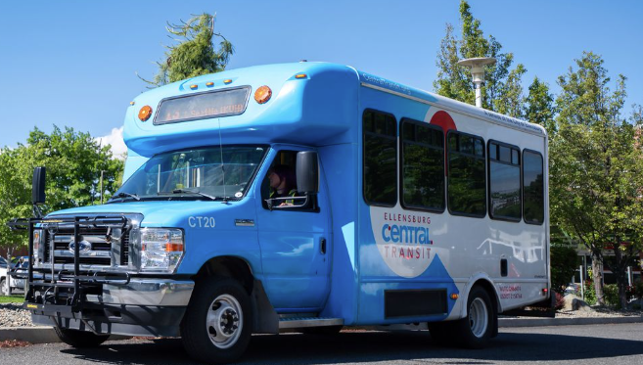

MISSION AND CORE VALUES

Mission

We advocate for a safe, efficient, reliable, accessible, and sustainable public transit system that enables all community members to meet their needs and participate in all that Ellensburg has to offer.

Core Values

Our core values serve as the guiding principles that shape how we interact with passengers, contractors, the community, and the environment.

Stewardship

We serve as responsible stewards for our passengers and the most vulnerable members of our community, the environment, and public funds. Through efficient use of resources, we will ensure the long-term sustainability of our transit system.

Collaboration

We value public feedback and build strong partnerships to improve mobility, expand options, and foster innovation.

Adaptive

We ensure a system that listens to and adapts to our communities' evolving needs.

Safety

We establish and enhance safe transit operations and transportation infrastructure.

Professionalism

We believe that professionalism is demonstrated through consistent reliability, courteous service, and a strong commitment to safety. Every interaction with passengers, whether in person or online, reflects our dedication to excellence and respect for the community we serve.

STRATEGIC PRIORITIES

Funding and financial sustainability

We secure diverse funding sources, including local funds, grants, and strategic partnerships, to support system growth and resilience while ensuring long-term financial sustainability.

Service expansion and efficiency

We strive to expand service hours, frequency, and geographic coverage whenever possible to meet evolving community needs while ensuring equitable access for all.

Fleet Modernization and Improvements

We seek to run a reliable fleet that aligns vehicle size and features with service demands, improves the rider experience, and promotes long-term climate health and environmental goals.

Improve system infrastructure and access

We are committed to building a safe, connected, efficient, comfortable, and accessible transit system through investments in a transit hub and facility upgrades when fiscally able, along with continued regional coordination.

Communication, public awareness, and engagement

We build trust, awareness, a positive public image, and increased ridership through clear, consistent signage, targeted outreach, and marketing.

Trust
Sustainability
Equity
Reliability
Safety

THE AGENCY

In 2011, the City of Ellensburg, Central Washington University, HopeSource, and WSDOT collaborated to plan, fund, and operate a public transit service in Ellensburg. In 2013, the first Transit Development Plan was completed; in 2015, the Ellensburg Transit Benefit District was created, and the Ellensburg City Council became the official board. In 2016, the Ellensburg City Council authorized a special election for a sales and use tax of .02% to fund public transit. It passed with 63% voter approval; however, the funding would expire every ten years. In 2017, the City of Ellensburg assumed operation of Ellensburg Central Transit. In 2025, the Ellensburg Transit System Ballot Measure, Resolution No. 2025-14, was put on the ballot to repeal and replace the Transit Benefit District Resolution No 2025-15 with a 0.2% Transit Tax that does not expire. The voters approved the ballot measure with 65.3% voter approval.

ECT is a rural public transit system serving residents and visitors within the city limits of Ellensburg, Washington. Situated east of the Cascade Range at the junction of Interstates 90 and 82, Ellensburg is recognized as the most centrally located city in the state. The area offers four distinct seasons, with convenient access to nearby mountains for skiing and hiking, and the Yakima River for fishing and rafting. The community also hosts numerous special events, such as the Ellensburg Rodeo.

Ellensburg is home to Central Washington University, which provides funding support for the transit system along with the Washington State Department of Transportation.

The city’s 2025 population is estimated at 21,308.

GOVERNING BODY
The City of Ellensburg is a Council-Manager form of government, with a seven-member City Council elected at large for four-year terms. The current council members and their terms are as follows:

Rich Elliott | Position 6 | Term - 2024-2027 (also serves as Mayor)
Sarah Beauchamp | Position 7 | Term - 2024-2027
Nancy Lillquist | Position 1 | Term – 2026-2029
Nancy Goodloe | Position 2 | Term - 2026-2029
David Miller | Position 5 | Term - 2024-2027
Joshua Thompson | Position 4 | Term - 2024-2027
Delano Palmer | Position 3 | Term - 2026-2029

The City Council meets on the first and third Mondays of each month at 7:00 p.m. in the City Council Chambers at City Hall located at 501 N. Anderson St., Ellensburg, WA 98926. Meetings are open to the public and can be attended virtually via Zoom or watched on the ECTV YouTube Channel, Ellensburg, WA | Official Website. The Zoom link for the meeting will be found in the published agenda packet.

For more information, agendas, and minutes, visit the official City Council page on the Ellensburg website. Ellensburg, WA.

ORGANIZATION

The Ellensburg City Council oversees the operations of Ellensburg Central Transit. The Ellensburg Transportation Advisory Committee provides guidance and oversight of the transit system, reporting directly to the City Council on these and other matters as directed. The Transit Manager is responsible for the day-to-day administration and operational management of the Transit System.

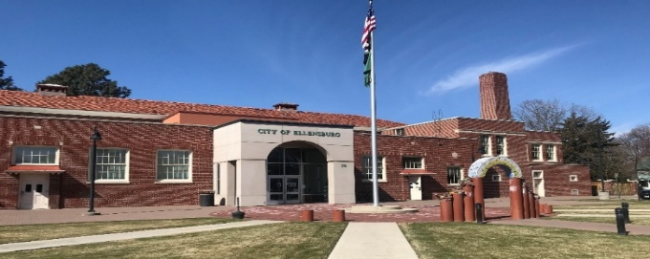

ETAC
CITY COUNCIL

CITY MANAGER

PUBLIC WORKS DIRECTOR

TRANSIT MANAGER

CONTRACTOR

AGENCY STRUCTURE

The Transit Department is a division of the City of Ellensburg’s Public Works Department.
Leadership Team
Heidi Behrends Cerniwey | City Manager
Ryan Lyysiki | Public Works Director
Josh Mattson | Assistant City Engineer
Betsy Dunbar | Transit Manager

The Ellensburg Transportation Advisory Committee (ETAC) plays a vital role in advocating for public transit in Ellensburg. ETAC’s responsibilities are to advise and make recommendations to Council pertaining to the operations and improvements of public transit within the city. Committee members develop and implement community outreach programs, provide advice and recommendations to the City’s transit provider, Council, and staff concerning the City’s transit system, and report at least annually to Council on matters as they pertain to the City’s public transit system.

ETAC meetings occur on the third Tuesday of every month. The schedule of regular meetings can be found on the City of Ellensburg website. Employees and the public are welcome to attend in person or virtually.

Nancy Lillquist - Chair | Ellensburg – Council Appointed
Jim Hurson – Vice Chair | Ellensburg Resident
Ann Miner | Ellensburg Business Owner
Carol Chrisman | Ellensburg – ESD Appointed
Michael Montgomery | Ellensburg – CWU Appointed
Alex Matheson | ASCWU Representative
Committee Member | Open
Alternate Member | Open

The Transit Manager serves on a variety of boards and committees representing Ellensburg Central Transit.

- Board Member, Washington State Transit Association (WSTA)
- Board Member, Washington State Transit Insurance Pool (WSTIP)
- Board Member, Community Transportation Association of the Northwest (CTANW)
- Staff Member/Oversight, Ellensburg Transportation Advisory Committee (ETAC)
- Board Member, Four-County Community Transportation Planning Team

SERVICES (Required Element)
Fixed Route
ECT provides six ﬁxed routes that operate daily between 6:55 am and 8:15 pm within the city limits of Ellensburg. The system maps show the locations of each route, the direction of bus movement, scheduled bus stops, on-demand bus stops, bus shelters, and transfer service points.

Route 12 A: 7:10 AM to 7:45 PM serves Central Washington University and the north and south ends of the City.
Route 12 B: 7:40 AM to 8:15 PM serves Central Washington University and the north and south ends of the City.
Route 13: 6:57 AM to 7:15 PM serves north to Elmview and south to Kittitas Valley Healthcare.
Route 14: 6:55 AM to 6:45 PM serves north to Bender and south to Ellensburg High School.
Route 15: 7:55 AM to 7:20 PM serves downtown and the southwest side of Ellensburg.
Route 16: 7:30 AM to 6:50 PM serves downtown and the northwest side of Ellensburg.

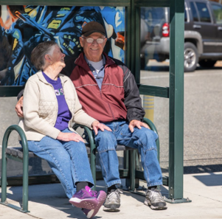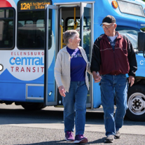

ADA Paratransit
In compliance with the Americans with Disabilities Act, ECT provides accessible door-to-door service within a three-quarter-mile corridor of the ﬁxed route system for passengers who are unable to access the ECT fixed route system due to a disability.

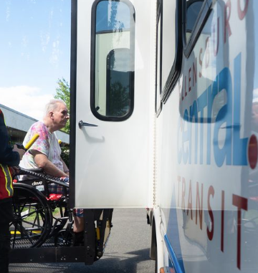

NEMT Cabulance

ECT’s non-emergency medical transportation service, known as Cabulance, is independent from ECT's Public Transit services and operates 24/7, 365. The service provides transportation for individuals within the Ellensburg city limits to and from specific medical facilities as requested by Kittitas Valley Healthcare and other contracted facilities.

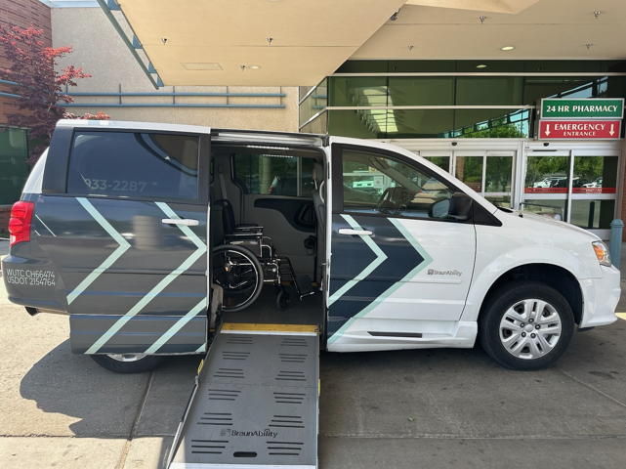

City Limits of Ellensburg Map
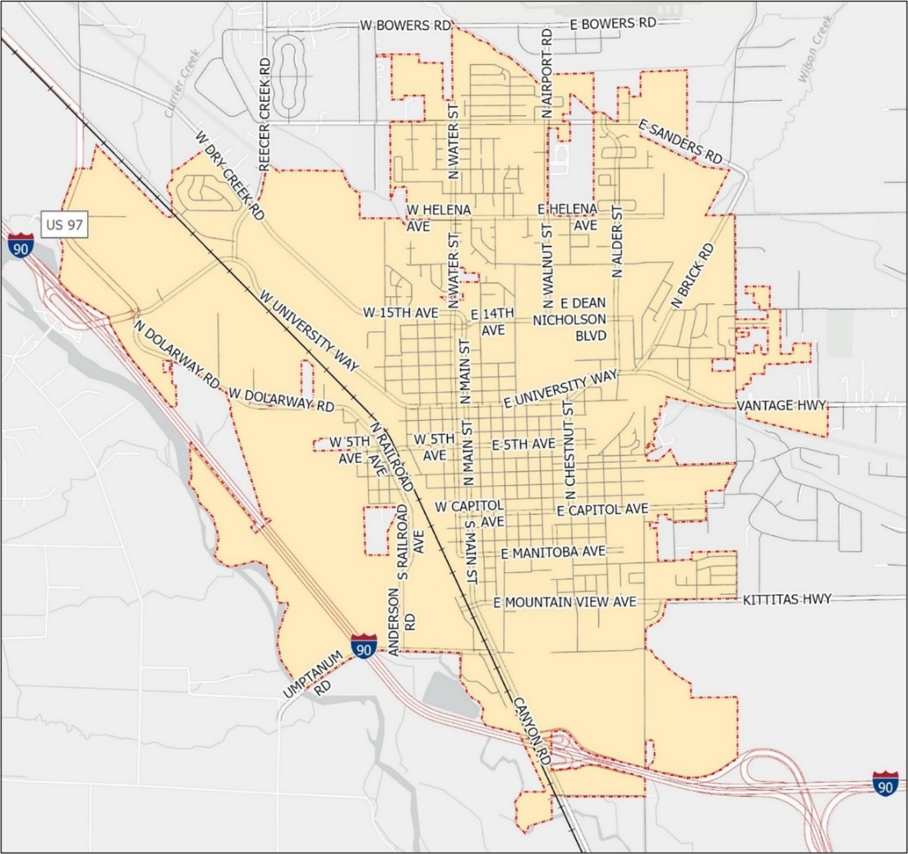

Live Interactive Fixed Route Map

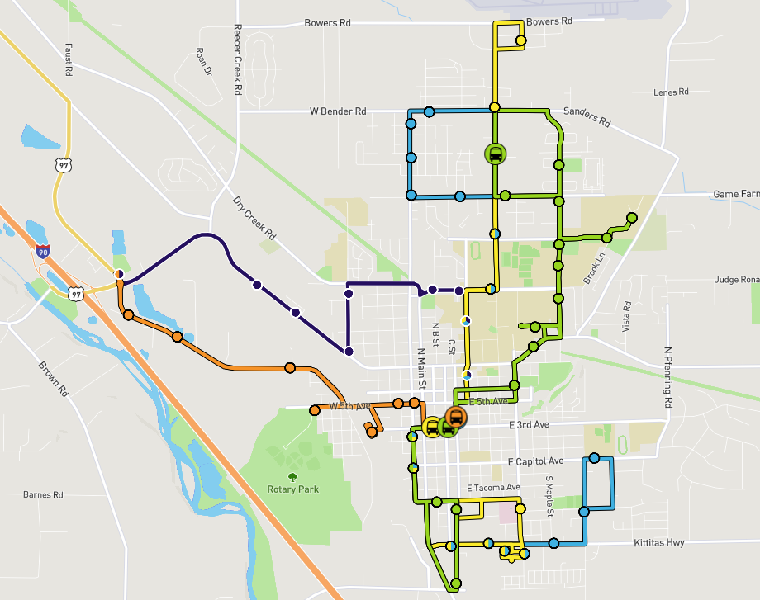

PEDESTRIAN AND BIKE PATHS
At ECT, almost every trip starts and ends with walking. That’s why we prioritize connecting our buses with safe sidewalks, bike lanes, and trails. Every bus is equipped with two bike racks. Our goal is to build a seamless multimodal system that makes getting around safer, easier, and more efficient for everyone.

Ellensburg’s flat terrain makes it especially easy and practical for many community members to walk or bike.

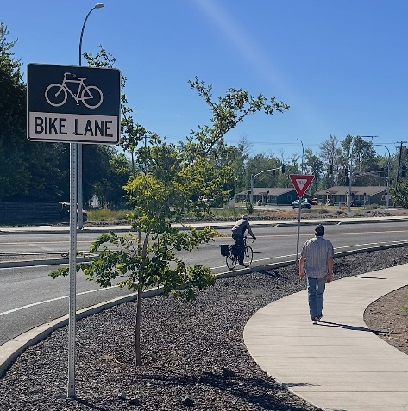
REGIONAL CONNECTIONS
Beyond ECT services, several regional connections are available through partner transit providers. Yakima Transit operates Route 11, which connects Ellensburg, Selah, and Yakima on weekdays. Pick-up and drop-off locations in Ellensburg include Umptanum Street and Ruby Avenue, the Ellensburg Safeway, and East 11th Avenue & Maple Street.

Connections to Cle Elum are provided by HopeSource’s Kittitas County Connector, which operates daily between Ellensburg and Cle Elum with a Loop to Roslyn and Ronald twice daily. HopeSource also offers service between Ellensburg and Kittitas on Tuesdays, Thursdays, and Saturdays.

Regional service to Omak is available daily via Travel Washington’s Apple Line. Connections to Seattle-Tacoma International Airport and the SeaTac light rail station are provided daily by the Bellair Airporter Shuttle. Additionally, FlixBus and Greyhound offer regional travel options based on passenger needs.

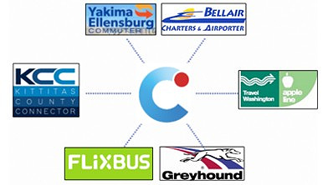

FACILITIES & EQUIPMENT

Bus Stops & Shelters

ECT currently has 81 bus stops, including 19 bus shelters. Two additional bus shelters are planned for 2026. All bus shelters include artwork from local artists.

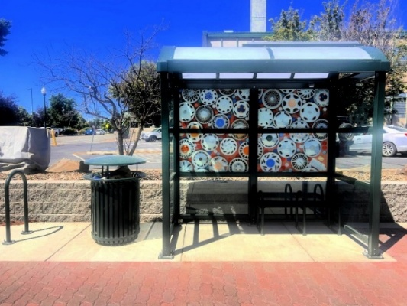

Transit Hub
ECT currently uses the 4th and Ruby Street downtown location as its transit hub.

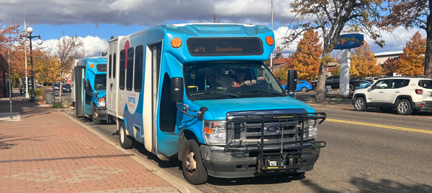

Contractor Bus Facility

All the operational equipment is owned and maintained by HopeSource, located at 606 W 3rd Avenue in Ellensburg, Washington. The transportation department offices are located next door at 607 W 3rd Avenue.

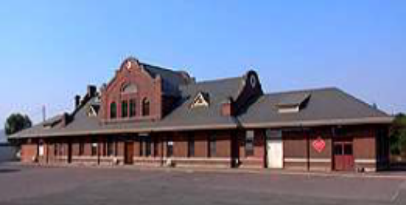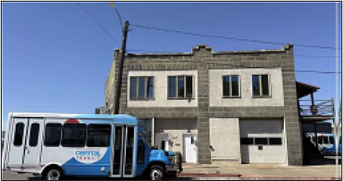

Equipment

Our contractor, HopeSource, supplies the transportation facility with staff members and vehicles.

No. | Year | Make/Model | Vehicle Number | ADA | Seating | Fuel Type
1 | 2017 | Ford / E450 | CT-7 | Yes | 12+2 | G
2 | 2017 | Ford / E450 | CT-6 | Yes | 12+2 | G
3 | 2018 | Ford / E350 | CT-9 | Yes | 12+2 | G
4 | 2019 | Ford / E450 | CT-8 | Yes | 12+2 | G
5 | 2021 | Ford / E450 | CT-10 | Yes | 12+2 | G
6 | 2021 | Ford / E450 | CT-11 | Yes | 12+2 | G
7 | 2021 | Ford / E450 | CT-12 | Yes | 12+2 | G
8 | 2023 | Ford / E450 | CT-20 | Yes | 12+2 | G
9 | 2016 | Dodge/Caravan | 100 | Yes | 2+1 | G
10 | 2023 | Chrysler/Voyager | 107 | Yes | 3+2 | G
11 | 2023 | Chrysler/Voyager | 109 | Yes | 3+2 | G
12 | 2025 | Ford/Transit | 110 | Yes | 8+2 | G

2025 PERFORMANCE AND STATISTICS
System Performance
In 2025, the fixed-route ridership was 115,740. The average weekday ridership was 356, and the average weekend day ridership was 243.

In 2025, ADA paratransit ridership reached 703 trips, reflecting a 323% increase from 2024. Despite this growth, it represented only 0.6% of the total system ridership.

The NEMT Cabulance service ridership reached 313, a 56% increase from the previous year.

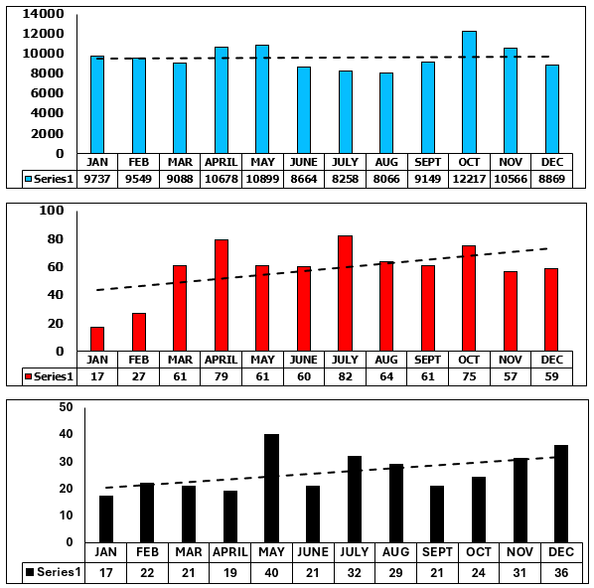
CABULANCE
FIXED ROUTE
ADA PARATRANSIT

The overall operating statistics for Fixed Route, ADA Paratransit, and Cabulance in 2025 are shown in the table below.

Mode | Fixed Route | ADA Paratransit | Cabulance
Boardings | 115,740 | 703 | 313
Annual Revenue Miles | 239,198 | 2,854 | 628
Annual Revenue Hours | 21,201 | 395 | 481

CAPITAL PROJECTS

ECT remains committed to continuously improving transit service and the rider experience. To that end, it enforces strict on-time performance standards for its transit services contractor. ECT is also pursuing several key initiatives, including upgrading bus stops and bus shelters with artwork, bus pullouts, ADA-compliant landings, additional bench seating, and lighting; improving service accessibility and enhancing connections to non-motorized pathways and trails; implementing transit signal priority along key transit corridors; supporting the transition to zero-emissions vehicles and infrastructure; and advancing plans for an intermodal transit station or hub. These efforts will collectively enhance the quality, accessibility, and effectiveness of public transit in Ellensburg.
Title II of the Americans with Disabilities Act:

Title II of the Americans with Disabilities Act (ADA), enacted in 1990, is a civil rights law that protects individuals with disabilities from discrimination by public entities, including state and local governments, their departments, agencies, and other instrumentalities. Its primary goal is to guarantee equal opportunity and access to all public services, programs, and activities, regardless of the size of the government entity or whether it receives federal funding.

The responsibility for ensuring the implementation of this plan is vested in the Ellensburg City Council, the Ellensburg Transportation Advisory Committee, and Ellensburg Central Transit’s Transit Manager.

ADA Capital Improvements
ECT’s 2025 ADA Title II capital improvements included 13 ADA landing pads, the removal of 2 bus stops on 5th Avenue and their replacement with 1 stop along the Rotary Park roundabout with a bus shelter, an extra bench, and amenities. Two additional bus shelters with amenities were added at S 4th and Ruby St and at Ruby St and Umptanum.
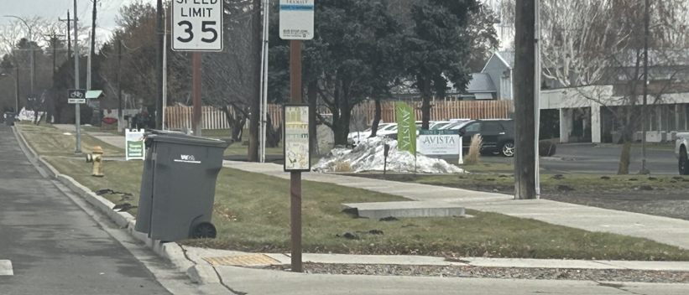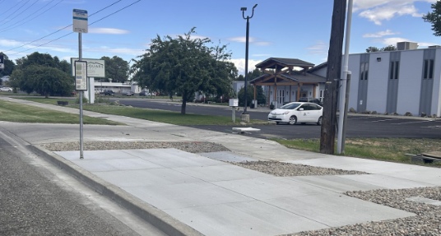
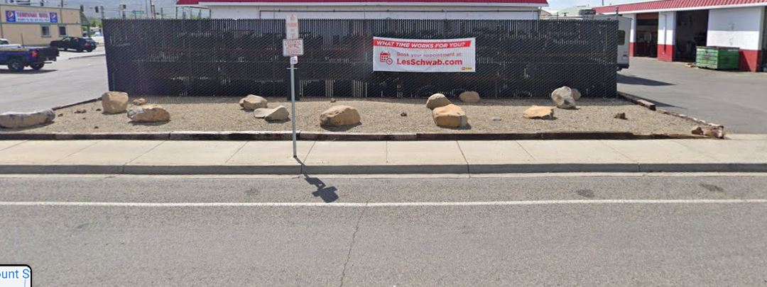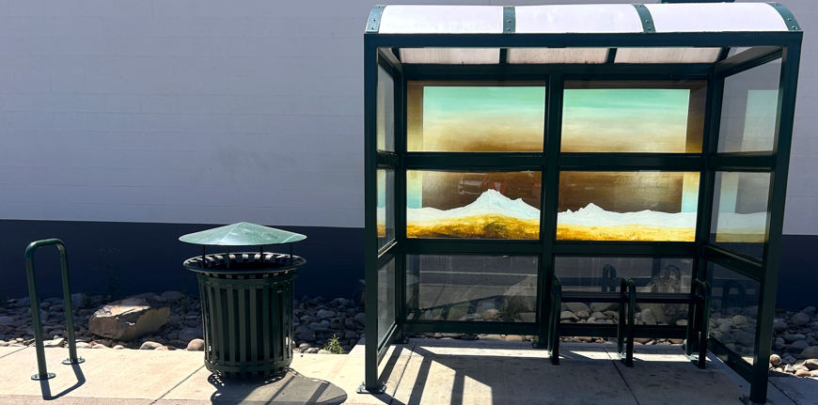

2026-2031 PLANNING SERVICE (Required Element)

Strategic Planning

A key component of this strategy is the completion and guidance of our Six-Year Transit Strategic Plan. The plan will provide directions on the future priorities of our transit system. The plan also provides a shared vision of where the system is headed and what the desired outcomes are. The main purpose of the plan is to aid in prioritizing funding needs and identifying areas of service improvement and expansion. Some goals include:

Community Requests
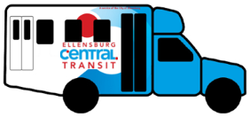
Update
schedules at
bus stops

A centralized Transit Hub
30-minute route schedules
Earlier and later bus service
More stops with benches and bus shelters for riders waiting for the bus
Add more stops to serve senior populations

Expand
Routes

WSDOT TRANSPORTATION GOALS
The Washington State Transportation Plan establishes six goals to guide agencies in developing and maintaining the state’s transportation system. The priorities and strategies outlined in the plan for ECT Services are fully aligned with those statewide transportation goals.
Economic vitality
Promote and develop transportation systems that stimulate, support, and enhance the movement of people and goods to ensure a prosperous economy.
Preservation
Maintain and preserve prior investments within our transportation system.
Safety
Provide for and improve the safety and security of transportation customers and the transportation system.
Mobility
Improve the predictable movement of people and goods throughout Washington State.
Environment
Enhance Washington’s quality of life through transportation investments that promote energy conservation, enhance healthy communities, and protect the environment.
Stewardship
Continuously improve the quality, effectiveness, and efficiency of the transportation system.
ECT 2026-2031 GOALS
Moving Forward

Economic Vitality | We support our local economy by connecting passengers to retail stores, entertainment, social services, community events, and our historic downtown.
Preservation | ECT works with our contractor to ensure strict vehicle maintenance schedules. We maintain and upgrade transit infrastructure to ensure our bus stops and bus shelters are safe and welcoming.
Safety | Our contractor performs pre-trip and post-trip inspections as well as daily service monitoring and provides ongoing training to operators. All buses are equipped with cameras with video and audio capabilities.
Mobility | ECT works to educate our community, so everyone has access to public transportation. Increase frequency to improve access and reduce wait times.  Rider Alerts publishes service alerts across multiple channels – apps, social media, SMS and websites with a single click. Riders can also subscribe to get rider alerts via email or text for the routes and bus stops they frequent. We promote rider apps and our Interactive website, where passengers can plan their trips and get live updates on when their bus will arrive at the bus stop.
Environment | We promote riding the bus, which benefits the environment. We will also work to progress with our Zero-Emissions Plan.
Stewardship | We maintain active coordination with WSDOT, the Regional Transportation Planning Organization, the Four-county Community Team, neighboring counties, and several state transportation organizations. Our Ellensburg Transportation Advisory Committee collaborated with a contractor to develop a comprehensive Six-Year Transit Strategic Plan. We continue to actively engage the community in planning and decision-making to ensure our transit services align with local needs and expectations.

FLEET
We encourage our contractor to transition to a zero-emissions fleet, including cutaways and smaller buses, as grant funding and affordable local match funds become available.

In the meantime, converting the existing buses to clean-operating propane-powered buses is a practical path forward to lowering fuel costs and improving air quality.

CAPITAL IMPROVEMENT & EXPANSION (Required Element)
Strategic Planning
Currently, our transit hub is located on the street, which has several significant drawbacks, including direct noise and air pollution, as well as requiring pedestrians to cross the street to connect to other buses.

The advantages of placing a transit hub off the street include reducing congestion at street intersections, lower traffic speeds, creating a safer environment for passengers, and improving the overall travel experience.

Currently, more than 90% of our bus stops are ADA-compliant, and we are on track to achieve 100% compliance within the next one to two years, subject to the ability to acquire rights-of-way.

Planning efforts will ensure that capital investments align with strategic priorities, while the transit budget will be the primary factor in determining which priorities to pursue.

CAPITAL PRESERVATION & REPLACEMENT (Required Element)
ECT will continue to inspect all bus stops and bus shelters to ensure passengers are safe while waiting for the bus. Our contractor supplies all the service vehicles.

FINANCIAL PLAN (Required Element)
ECT is primarily funded through local sales and use tax revenue, supplemented by state and federal pass-through grant funding. These grant resources play a critical role in sustaining our transit operations.
The figures below assume that fare-free transit will continue, sales tax revenue will stay strong, and state and federal funding will remain steady.

Annual Revenues

Annual Revenues | 2025 Actual | 2026  Projected | 2027  Projected | 2028  Projected | 2029  Projected | 2030  Projected | 2031  Projected
Sales Tax | 2,004,129 | 1,600,000 | 1,600,000 | 1,660,000 | 1,660,000 | 1,660,000 | 1,660,000
Central Washington University | 75,000 | 66,000 | 66,000 | 66,000 | 66,000 | 66,000 | 66,000
Local Grants | 5,000 | 5,000 | 5,000 | 5,000 | 5,000 | 5,000 | 5,000
State /Federal Grants | 1,300,000 | 1,270,000 | 1,600,000 | 1,600,000 | 1,600,000 | 1,700,000 | 1,700,000
Special Needs Formula Grants | 8,436 | 6,999 | - | 5,000 | - | 5,000 | -
Interest Income | 157,129 | 80,000 | 80,000 | 80,000 | 80,000 | 80,000 | 80,000
Operating Revenue Total | 3,753,541 | 4,439,999 | 4,183,000 | 4,320,000 | 4,448,280 | 4,587,226 | 4,716,850

Operating Expenses
Operating Expenses | 2025 Actual | 2026  Projected | 2027  Projected | 2028  Projected | 2029  Projected | 2030  Projected | 2031  Projected
Fixed Route | 1,390,000 | 1,852,000 | 2,192,464 | 2,236,313 | 2,281,039 | 2,326,659 | 2,373,192
ADA Paratransit | 20,239 | 29,200 | 38,000 | 38,760 | 39,535 | 40,326 | 41,132
NEMT Cabulance | 74,078 | 49,039 | 50,000 | 51,000 | 52,020 | 54,120 | 58,580
Administration | 1,197,000 | 1,081,400 | 1,042,000 | 1,213,700 | 1,248,324 | 1,273,290 | 1,298,755
Yakima Transit | 20,000 | 40,000 | 40,000 | 40,000 | 40,000 | 40,000 | 40,000
HopeSource Dial A Ride | 82,313 | 82,313 | 82,313 | 82,313 | 82,313 | 82,313 | 82,313
HopeSource KCC | 44,000 | 44,000 | 44,000 | 44,000 | 44,000 | 44,000 | 44,000
Insurance | 50,000 | 50,000 | 50,000 | 50,000 | 50,000 | 50,000 | 50,000
Marketing | 104,700 | 50,000 | 50,000 | 50,000 | 50,000 | 50,000 | 50,000
Operating Expenses Total | 2,982,330 | 3,277,952 | 3,588,777 | 3,806,086 | 3,887,231 | 3,960,708 | 4,037,972

Capital and Operating Improvement Estimated Financial Plan
Projects and Estimated Expenses
ECT projects a steady increase in operating expenses for the years 2026-2031 due to the inflation of goods and services, rider-facing technologies, and community requests for expanded hours and locations. These projections underscore the ongoing financial planning required to support operations and potential growth.

Capital expenditures | 2026 | 2027 | 2028 | 2029 | 2030 | 2031 | Future  Predictions
Transit Hub |  |  |  | $2,200,000
Colored magnets and numbers for the side and back of the bus | $1,500
Bus Shelters, benches,  trash receptacles,  bike racks and solar  lighting | $80,000 | $40,000 | $40,000 | $40,000 | $40,000 | $40,000
Additional Bench Seating | $10,000 | $10,000 | $10,000 | $10,000 | $10,000 | $10,000
Bus Shelter Artwork & Installation | $22,000 | $11,000 | $11,000 | $11,000 | $11,000 | $11,000
Movement of Signage | $16,000 | Review | Review | Review | Review | Review
Transit Connection Improvement |  | $215,000 | $70,000
Improved accessibility and connections to non-motorized pathways and trails | $211,000 | Review | Review | Review | Review | Review
Additional turnouts & lighting | $35,000 | Review | Review | Review | Review | Review
Expanded Route Times | 0.00 | Review |  |  |  |  | $99.00 per additional Service Hour
30-minute route wait times | 0.00 |  |  |  |  |  | Unknown
Expanded route/routes | 0.00 |  |  |  |  |  | $99.00 per additional Service Hour
Marketing | $40,000 | $40,000 | $40,000 | $50,000 | $50,000 | $50,000
CPI Increases | $0.00 |  |  |  |  |  | 0.2-11%
Travel Training | 0 |  |  |  |  |  | Unknown
Bus Monitors | $5,000 | 0 | 0 | 0 | 0 | 0
Transit Signal Priority |  |  |  |  | $350,000
Propane Conversion | Review | Review |  |  |  |  | Unknown

