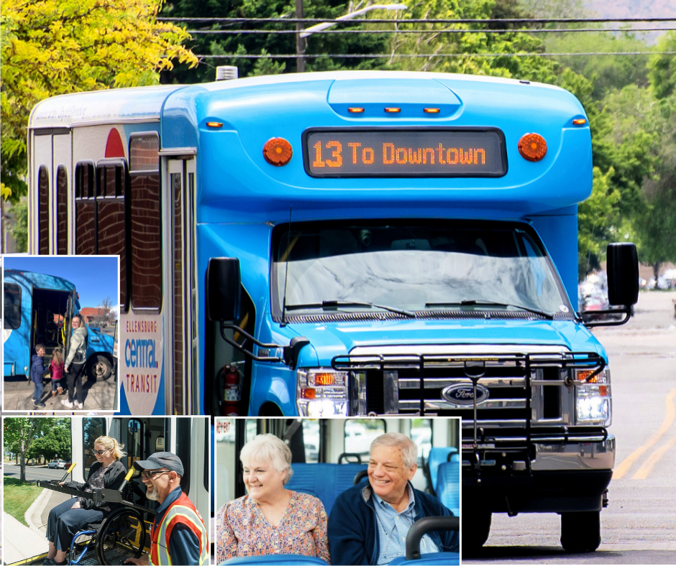

TRANSIT STRATEGIC PLAN
2025-2030
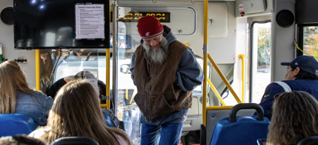
Adopted by the Ellensburg City Council – August 3, 2026.

Table of Contents
ACKNOWLEDGEMENTS 2
APPROVAL 3
ADOPTION 3
Executive Summary 4
Vision 4
Mission 4
Core Values 4
Strategic Priorities 5
About Ellensburg Central Transit 6
Data-Informed Planning 8
Ridership Data 8
Rider Surveys 9
Community Feedback Survey 9
Stakeholder Interviews 12
Strengths, Weaknesses, Opportunities, Limitations, Threats Analysis 14
Strategic Plan Implementation 17
Appendix A 26
Community Survey Respondents 26

ACKNOWLEDGEMENTS
This five-year strategic plan for Ellensburg Central Transit was developed by members of the City of Ellensburg Transportation Advisory Committee (ETAC) in partnership with City of Ellensburg staff members, a contractor representative, and Robin Read, Community Consultant.
Per City code, the Ellensburg Transportation Advisory Committee shall advise and make recommendations to Council pertaining to infrastructure planning, maintenance and operation, and improvements of public transit and the complete street transportation system within the City, develop and implement a community outreach program, provide advice and recommendations to City’s transit provider, Council and staff concerning the City’s transportation system, and report at least annually to Council on matters as they pertain to the City’s public transit and transportation system.

ETAC Members 2025-2026
David Miller, Ellensburg City Council
Nancy Lillquist, Ellensburg City Council
Michael Montgomery, Central Washington University
Alex Matheson, Associated Students of Central
Washington University
Carol Chrisman, Ellensburg School District
Jim Hurson, Community Member
Anne Miner, Community Member
Deja Blanchard, Community Member

City of Ellensburg Staff Members
Heidi Behrends-Cerniwey, City Manager
Betsy Dunbar, Transit Manager
Ryan Lyyski, Public Works Director
Josh Mattson, Assistant City Engineer
Derek Mayo, City Engineer

Contractor Representative
Keiko Walsh, HopeSource

APPROVAL
The ETAC approved the final plan and recommended its adoption to the Ellensburg City Council on July 14, 2026.

ADOPTION
The Ellensburg City Council adopted the 5-year Transit Strategic Plan on August 3, 2026.

Executive Summary
This strategic plan provides directions to the Ellensburg Transportation Advisory Committee (ETAC) on the future priorities of the Ellensburg Central Transit system. The plan provides a shared vision of where the system is headed and what the desired outcomes are. The purpose of the plan is to help prioritize funding needs and identify areas of service improvement and expansion.
During the strategic planning process, the following vision, mission, and value statements were developed by the ETAC Members.

Vision
We strive to create a seamless, reliable, accessible, safe, and sustainable transit system that enables all community members to meet their needs and participate in Ellensburg life.

Mission
We advocate for a safe, efficient, and reliable public transit system that reflects community needs and creates access for all.

Core Values
- Stewardship: We promote responsible, efficient use of public resources to ensure long-term sustainability.
- Accessibility: We support removing obstacles to using public transportation and place a high priority on ADA compliance.
- Collaboration: We value public feedback and build strong partnerships to improve mobility, expand options, and foster innovation.
- Adaptive: We ensure a system that listens and adapts to the community’s evolving needs.
- Safety: We establish and enhance safe transit operations and transportation infrastructure.

Strategic Priorities
Through analyzing transit system data, community feedback data, and conducting Strengths, Weaknesses, Opportunities, Limitations, and Threats analysis, ETAC identified 5 high-level strategic priorities and goals:
- FUNDING AND FINANCIAL SUSTAINABILITY
  - Goal: Secure and diversify funding sources to support system growth and resilience by leveraging local funding, grants, and partnerships to ensure financial sustainability.
- SERVICE EXPANSION AND EFFICIENCY
  - Goal: Expand service hours, frequency, and geographic coverage to meet evolving community needs while ensuring equitable access.
- FLEET MODERNIZATION AND IMPROVEMENTS
  - Goal: Build a sustainable fleet that aligns vehicle size and features to service demands; improves rider experience; and promotes long-term climate, health, and environmental goals.
- IMPROVE SYSTEM INFRASTRUCTURE AND ACCESS
  - Goal: Develop a safer, connected, efficient, comfortable, and accessible transit system by investing in a transit hub and facility upgrades and expanding regional coordination.
- COMMUNICATION, PUBLIC AWARENESS AND ENGAGEMENT
  - Goal: Build trust, awareness, a positive public image, and increased ridership through clear, consistent signage, targeted outreach, and marketing.

About Ellensburg Central Transit
Starting in 2011, the City of Ellensburg, the Associated Students of Central Washington University (ASCWU), HopeSource, and the Washington State Department of Transportation (WSDOT) collaborated to plan, fund, and operate public transit service within Ellensburg.
In 2015, the City of Ellensburg established the Ellensburg Transportation Benefit District (TBD) to finance Ellensburg public transportation improvements. The legislature subsequently amended the existing laws, enabling the City to end the separate entity status of the TBD and assume its rights, powers, functions, and obligations.
At its January meeting, the city council authorized an election for April 26, 2016, for a sales and use tax. The tax was to be levied in an amount of up to two-tenths of one percent for a period of not more than ten years to pay for or finance public transportation improvements. Ellensburg voters approved the levy with a 63% majority. With the TBD being absorbed by the City of Ellensburg and an assured form of funding, the City assumed operation of Ellensburg Central Transit on July 1, 2017.
The commitments made to the citizens of Ellensburg during the sales tax levy campaign motivated several positive changes for Ellensburg Central Transit. At the time of the City’s assumption, the fixed-route bus service expanded from two to six routes with additional stops and service hours, and an ADA paratransit service for passengers unable to access the fixed-route service due to a disability was added. Months later, a cabulance service was added.
In 2025, residents voted to make the sales and use tax permanent, showing a clear commitment to supporting Ellensburg Central Transit into the future. The City contracts all transportation operations to HopeSource, a local private non-profit organization.
- Fixed Route Service: Ellensburg Central Transit’s fixed-route service is a fare-free public transit service that operates daily, except for most national holidays. The buses operate 6 fixed routes within the city on an hourly basis and connect passengers with many shared-use biking and pedestrian trails. All buses are ADA accessible and equipped with bike racks.
- Paratransit Services: In compliance with the Americans with Disabilities Act, Ellensburg Central Transit provides accessible door-to-door transportation services for individuals who, because of a disability, are unable to travel on Ellensburg Central Transit’s fixed-route service.
- Cabulance: Ellensburg Central Transit’s Cabulance service operates independently 24-7 to provide accessible non-emergency medical transportation for individuals within the City limits of Ellensburg to and from contracted medical facilities as initiated by Kittitas Valley Healthcare and other contracted facilities.

Data-Informed Planning
To help guide the development of key strategic priorities, the ETAC analyzed ridership data, rider surveys, a community feedback survey, stakeholder interviews, and Strengths, Weaknesses, Opportunities, Limitations, and Threats analysis (SWOLT). A summary of these findings is provided below.

Ridership Data
Ridership has steadily increased over time and swiftly recovered from COVID-19 pandemic-related declines.
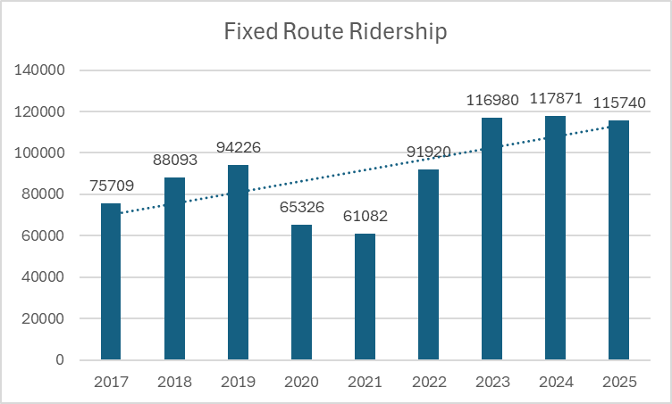
Paratransit ridership declined significantly in 2020 due to Covid19. The recent growth shows a rebound in ridership.
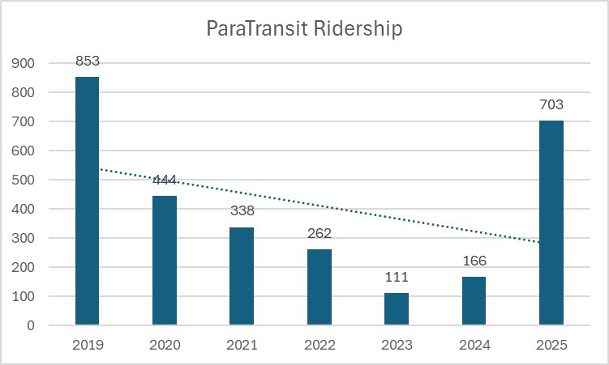

Cabulance usage has increased over time, driven by growing awareness of the service.
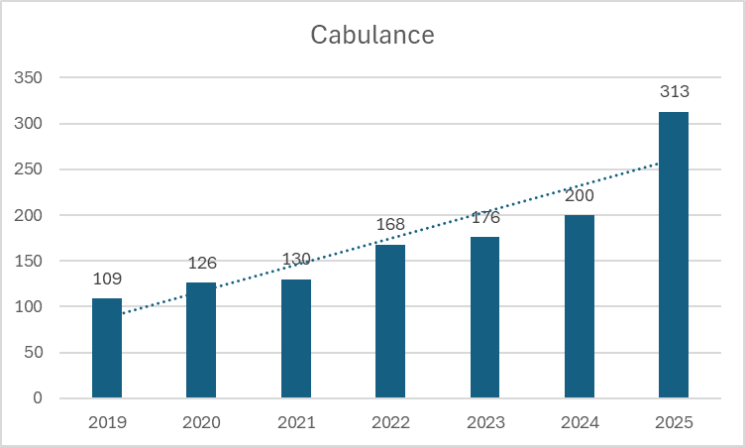

Rider Surveys
Rider surveys were conducted with 13 fixed route participants on Rural Transit Day in July 2025. The key findings included:
- Passengers use the service with frequencies ranging from daily to weekly.
- People use the bus for shopping, medical appointments, work, accessing social services, getting to classes, and participating in the community.
- Passengers appreciate the free and convenient service, along with the friendly and helpful drivers.
- While many passengers reported positive experiences, some identified opportunities for improvement, including lift reliability issues, excessive information at bus stops, inadequate lighting at stops, and the need for more frequent bus stops. It is easy for people to get to bus stops.
- Several options were shared to encourage ridership, including avoiding winter driving, free rides, promoting community events, and saving money on gas.

Community Feedback Survey
The community survey consisted of 3 screening questions, 9 content questions (2 open-ended), and 5 demographic questions. Participants who completed the survey were entered into a drawing to win a $15 gift card. There were 106 responses over one month of distribution. Distribution included flyers, social media, partner organizations, and a press release.
Sixty-six percent of respondents were female, half were between the ages of 35-54, 84% were white, 8% were Hispanic or Latino, and 16% were associated with Central Washington University (student, faculty, or staff). Over half of respondents rarely or never use Ellensburg Central Transit services, with about 24% using it weekly or daily. Of those who used services, 85% used the fixed route service, and 15% used the cabulance or paratransit services. Demographic and respondent graphs are located in Appendix A.
The most common reasons for using ECT services were shopping, employment, social and leisure activities, and medical appointments.
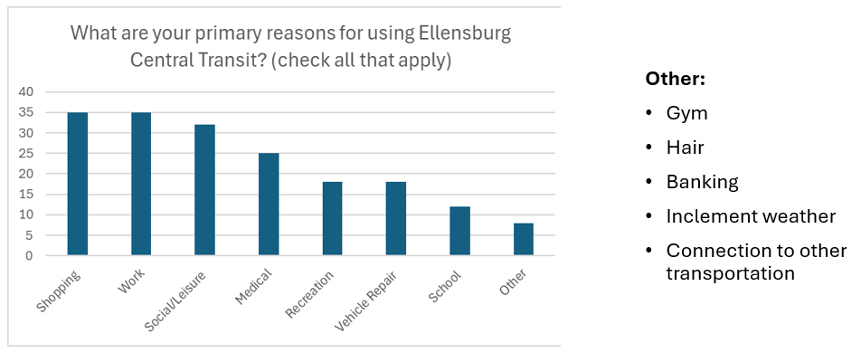
Respondents who reported rarely or never using ECT services gave reasons for preferring other transport and not having the service nearby. Other reasons cited included lack of knowledge about services and the ability to walk.
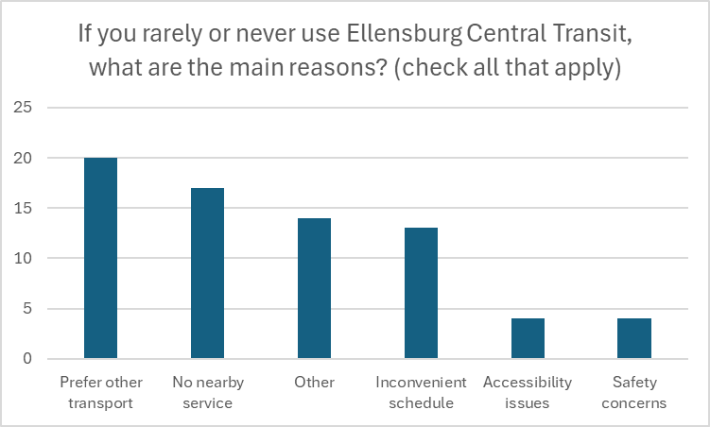
Approximately 15% of respondents expressed dissatisfaction with ECT services in their area.
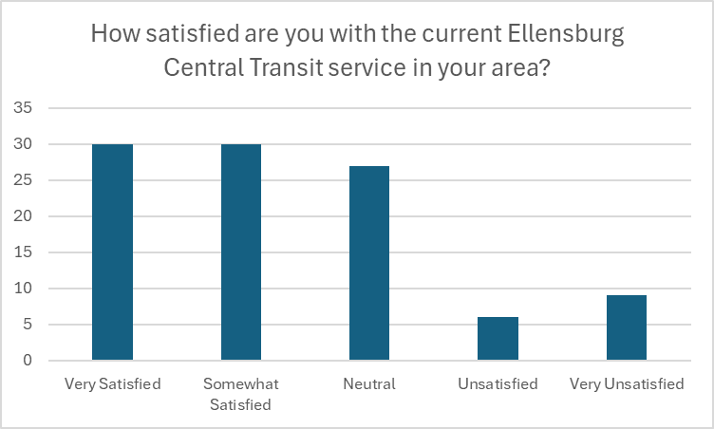
Key barriers to using ECT services included inconvenient route locations and scheduling, along with issues related to timing, distance between stops, and a lack of awareness.
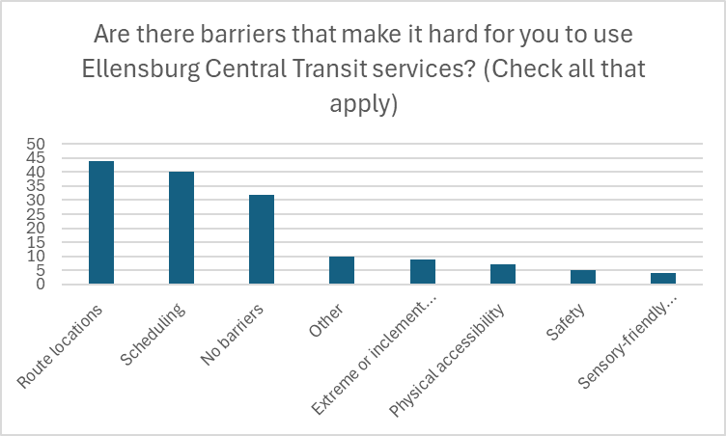
Scheduling and route locations were identified as the areas with the greatest potential for improvement.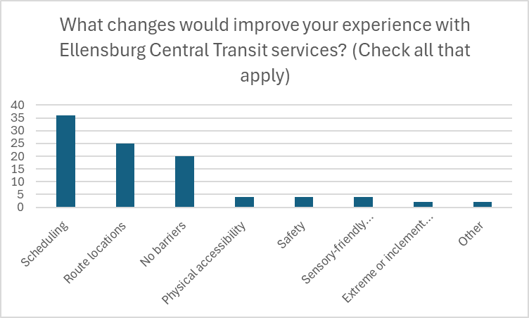
When asked to identify the top priority for improving ECT services, respondents most frequently cited expanded service – more routes, stops, frequency, and easy-to-read schedules – along with improved access to information and enhancements such as benches at bus stops and more bus shelters. Additional suggestions included on-bus storage, electric or hybrid buses, greater accessibility, cleanliness, timeliness, and aligning routes and schedules with ridership demand.
When asked if there was anything else they would like to share, respondents offered generally positive feedback about ECT, noting that drivers were friendly and helpful. Additional comments included requests for more stops, clearer information, and more connections to commuter buses. Some also expressed concerns about low ridership and limited accessibility for certain users.

Stakeholder Interviews
In August 2025, the consultant interviewed 6 community stakeholders, 3 staff members, and 4 advisory committee members. The following are the overarching themes that emerged from those interviews.

Meets a wide range of needs
Generally, many participants expressed that the transit system works well and meets a wide range of needs of people in the community. It covers a lot of area, especially for a rural small town, and the buses are generally easy to access. People use the transit system for work, appointments, shopping, and accessing services. The fact that the bus services are free helps a lot of people access what they need. The buses are generally accessible, the services are inclusive, and drivers are friendly, helpful, and accommodating.

Increasing accessibility
The overall vision of the participants is to increase accessibility to the transit system for all people in the community, with special consideration for those who rely on the transit system the most to meet basic needs and participate in the community. This may be accomplished primarily by expanding routes, increasing bus frequency, improving information, bus improvements, and increasing ADA accessibility.

Information improvements
There are some areas where information about transit services could be improved. While the cabulance and paratransit are seen as services that generally work well, there was concern that people may be unaware of their availability. Signage is another area of concern: signage at the stops is information dense and confusing for some, the signage inside the buses about where the bus stops and when is lacking or non-existent, and the buses only have numbers on the front, making it hard for people to see which bus it is. New users often don’t know how to ride the bus, and real-time information about bus arrivals can be inconsistent.
Organizations and the community should be more aware of the services, the fact that they are free, and the locations the buses serve. Additionally, scheduling information is confusing for many, and there could be opportunities to simplify information available and make it more accessible and easier to understand. The Transit app is helpful, but it isn’t always synced up with real-time information. More information needs to be available in Spanish as well.

Filling gaps
Gaps that were expressed included needing earlier and later times for buses, increased frequency, especially for routes that are hourly, and increasing routes to serve more areas. There is concern that the services aren’t available outside of the city limits.
There were discussions about the need to expand routes to cover more areas of the city and concerns about areas within the city that are not being served, which include the east side of town (Chestnut Street and Radio Hill) and the northwest part of town. There are also gaps in the northwest part of town, and the south of town has limited service. We need to ensure we continue to have sufficient service in the north part of town to serve CWU. In addition, concerns were raised about the lack of transit services in Kittitas and Vantage.
Many participants commented on the need for higher frequency, particularly on routes that are currently only hourly. Thirty-minute intervals would be more convenient for riders, reduce waiting times, and potentially increase ridership.

Infrastructure improvements
A frequent topic was adding more bus shelters to bus stops and increasing accessibility at stops. It would be beneficial to reduce the amount of information at bus stops to convey only the pertinent information for each bus stop. There was also concern expressed about the difficulties posed by parked cars in or near bus stops.
There were some questions about whether bigger buses will be needed in the future. Routes serving CWU are often cramped, and this may become a greater issue as ridership increases. A drawback to this would be that drivers would need CDLs. It was mentioned that while the buses are generally clean and drivers are friendly, the TV monitors are often not working. Additionally, there was discussion about changing the buses to electric, hybrid, or propane to lessen the impact on the environment and keep up with plans to reduce emissions. These modifications have several disadvantages, including price, sustainability, and battery life.

Strengths, Weaknesses, Opportunities, Limitations, Threats Analysis
A modified SWOT analysis (adding L for limitations) was conducted during a strategic planning retreat in November 2025 with the Ellensburg Transportation Advisory Committee, City of Ellensburg staff, and a contractor representative from HopeSource.

Strengths / Assets
1. Strong Public Reputation & Trust
- Positive brand
- Public support
- Good safety record
- Established system
2. Operational Reliability & Growth
- Reliable service
- Documented ridership growth
- Track record of steady expansion
3. Modernization & Infrastructure Improvements
- Capital improvements completed
- New bus shelters
- Logo update
- GPS + real‑time ETA tools
- Interactive website and rider apps
4. Strong Partnerships & Governance
- Good relationship with contractor
- ETAC as an engaged advisory body (board)
- Healthy cash balance (reserve)

Weaknesses / Areas for Improvement
1. Service Limitations
- Short service hours
- Long wait times / low frequency
- Small buses limiting capacity
2. Communication & Visibility Gaps
- Public unaware of service
- Signage clarity issues
- Need simpler, more effective communication
- Lack of coordinated communication strategy
3. Accessibility & Rider Experience
- Need more ADA improvements
- Unclear or insufficient signage
- Driver training communicated
4. Operational Structure
- No centralized operations
- Transit Hub needs attention

Opportunities
1. Strategic Growth & Route Refinement
- Measured expansion
- Refining routes to better serve demand
- Exploring new service areas (Millpond, Currier, Radio Hill, Black Horse)
- Facility improvements (including hub)
2. Revenue & Funding Potential
- Advertising revenue
- Sponsorships
- Grant funding
- Levy passage providing stability
- Reliable funding for long‑term decisions
3. Community Engagement & Partnerships
- Outreach to specific rider groups
- Coordination with other transit providers

Limitations
1. Funding & Resource Constraints
- Limited funding
- Small buses restrict service options
- Limited luggage/storage capacity
2. Geographic Boundaries
- Service restricted to city limits
- Limited ability to serve Kittitas
3. Infrastructure Challenges
- Transit Hub lacks space
- Signage on buses (especially rear)
- Low bus recognition in the community
4. Organizational & Legal Constraints
- Need stronger partnerships
- Potential lawsuits

Threats
1. Political & Financial Instability
- Political shifts
- Rising expenses
- Reduced access to grant funding
2. Operational Vulnerabilities
- Staffing shortages
- Driver recruitment challenges
- Weather impacts
- Bus availability or mechanical issues
3. Public Perception Risks
- Underutilized buses harming public image
- Pressure to meet carbon‑reduction expectations
- Need for future‑ready vehicle options

Strategic Plan Implementation
PRIORITY: FUNDING AND FINANCIAL SUSTAINABILITY
Goal | Secure and diversify funding sources to support system growth and resilience by leveraging local funding, grants, and partnerships to ensure financial sustainability.
Objectives | - Achieve alignment with the Transportation Improvement Plan annually.  - Submit at least 4 competitive grant applications per year that align with ECT priorities.  - Increase annual non‑tax revenue by 10% by 2030 through grants, sponsorships, and partnerships.  - Participate in at least 75% of the QuadCo and Four County Transportation Planning Team meetings.
Strategy 1 | Continue coordination, alignment, and inclusion with the City of Ellensburg Transportation Improvement Plan.
ACTIVITIES  (What are the activities that need to happen to implement this strategy?) |  | Target Date  (When should this activity be completed?) | Lead Persons  (Who is responsible for this activity?)
Annual review of projects/priorities |  | Q1 annually | Assistant City Engineer, City Engineer, Transit Manager
Review funding opportunities/status quarterly—check grants/fund |  | Quarterly | Assistant City Engineer, City Engineer, Transit Manager
Coordinate transportation and transit |  | Quarterly | Assistant City Engineer, City Engineer, Transit Manager
Review TSAP |  | Quarterly | Assistant City Engineer, City Engineer
Incorporate public comments |  | Quarterly | Assistant City Engineer, Transit Manager, City Engineer
Reports to the city council |  | Q2 annually | Assistant City Engineer, Transit Manager, City Engineer
Complete streets |  | Quarterly | Assistant City Engineer, City Engineer
Transit Development Plan |  | Q2 annually | Transit Manager
Strategy 2 | Strategically apply for grants to support ECT.
ACTIVITIES  (What are the activities that need to happen to implement this strategy?) |  | Target Date  (When should this activity be completed?) | Lead Persons  (Who is responsible for this activity?)
Get on listservs for transit grants |  | Ongoing | Assistant City Engineer, City Engineer
Determine what grants are available |  | Ongoing | Assistant City Engineer, Transit Manager, City Engineer
Evaluate needs vs. grant fit |  | Ongoing | Assistant City Engineer, Transit Manager, City Engineer
Evaluate strings—minimize conditions |  | Ongoing | Assistant City Engineer, Transit Manager, City Engineer
Achieve multiple city goals where possible |  | Ongoing | Assistant City Engineer, Transit Manager, City Engineer
Partnerships with regional groups for cross-agency projects. |  | Ongoing | Assistant City Engineer, Transit Manager, City Engineer
Strategy 3 | Combine transit/transportation projects to increase grant opportunities.
ACTIVITIES  (What are the activities that need to happen to implement this strategy?) |  | Target Date  (When should this activity be completed?) | Lead Persons  (Who is responsible for this activity?)
Review transit and transportation plans for common strategies and goals |  | 2026 | City Engineer, Assistant City Engineer, Transit Manager
Review grant opportunities |  | Ongoing | City Engineer, Assistant City Engineer, Transit Manager
Review other funding opportunities |  | Ongoing | City Engineer, Assistant City Engineer, Transit Manager
Apply for available grants |  | Ongoing | City Engineer, Assistant City Engineer, Transit Manager
Review transit and transportation plans annually to ensure strategies align with grant opportunities |  | Ongoing | City Engineer, Assistant City Engineer, Transit Manager
Strategy 4 | Continue active participation in QuadCo and the Four County Community Transportation Planning Team.
ACTIVITIES  (What are the activities that need to happen to implement this strategy?) |  | Target Date  (When should this activity be completed?) | Lead Persons  (Who is responsible for this activity?)
Participate in monthly meetings |  | Quarterly | City Engineer
Identify local transportation gaps to be eligible for WSDOT funding. |  | Ongoing | Assistant City Engineer, City Engineer, Transit Manager

PRIORITY: FLEET MODERNIZATION AND IMPROVEMENTS
Goals | Build a sustainable fleet that aligns vehicle size and features to service demands, improves rider experience, and promotes long-term climate, health, and environmental goals.
Objectives | - Complete a full Zero Emissions Plan review and update recommendations and agreements needed annually.  - Pilot at least one alternative fuel vehicle by Q4 2027 and produce a feasibility report.
Strategy 1 | Regularly review and revise the zero emissions plan on a regular basis based on new information and insights.
ACTIVITIES  (What are the activities that need to happen to implement this strategy?) |  | Target Date  (When should this activity be completed?) | Lead Persons  (Who is responsible for this activity?)
City staff to determine if strategies are still valid |  | Q2 2026 | Transit Manager
Infrastructure vs. equipment?  -Who does what?  -Readiness of each entity?  -Does that still apply? |  | Q2 2028 | Transit Manager
Review the plan  -financial (fed/state/local)  -environmental  -what has been built (state of infrastructure) |  | Q1 2028 | Public Works Director/Transit Manager/ETAC Adhoc
What agreements are needed to move forward? |  | To be determined | Transit Manager
Make it operational |  | 2030 | Transit Manager
Strategy 3 | Evaluate and test options for alternative fuel for buses
ACTIVITIES  (What are the activities that need to happen to implement this strategy?) |  | Target Date  (When should this activity be completed?) | Lead Persons  (Who is responsible for this activity?)
Combine with feasibility analysis |  | Q4 2027 | Transit Manager/Assistant City Engineer
Pilot project (start small) |  | 2027 | Transit Manager
Tied to the zero emissions plan |  | Q4 2027 | Transit Manager
Is it practical? |  | Q4 2027 | Transit Manager

PRIORITY: COMMUNICATION AND PUBLIC AWARENESS AND ENGAGEMENT
Goals | Build trust, awareness, a positive public image, and increased ridership through clear, consistent signage, targeted outreach, and marketing.
Objectives | - Create a subcommittee of at least 5 people to make signage and website recommendations by Q2 2026.  - By Q4 2026, standardize at least 90% of stops with new, uniform bus stop signage.  - Conduct annual outreach to at least 10 major employers to assess transportation needs and opportunities.  - Achieve full ADA compliance for the website by Q3 2027.  - Conduct public outreach/marketing through at least one venue quarterly.
Strategy 1 | Improve and simplify bus signage to facilitate rider information.
ACTIVITIES  (What are the activities that need to happen to implement this strategy?) |  | Target Date  (When should this activity be completed?) | Lead Persons  (Who is responsible for this activity?)
Create a subcommittee of ETAC and passengers to make recommendations to improve signage |  | Q3 2026 | Transit Manager
Research options for bus and bus stop signage |  | Q3 2026 | Contractor, Transit Manager
Design (#, color, figure?) |  | Q3 2026 | Transit Manager
Create and install |  | Q3 2026 | Transit Manager
Strategy 2 | Conduct outreach to local employers to share local transit resources.
ACTIVITIES  (What are the activities that need to happen to implement this strategy?) |  | Target Date  (When should this activity be completed?) | Lead Persons  (Who is responsible for this activity?)
Conduct outreach to large employers (over 100 employees) and ask for input on needs, timing of routes, time/day of route, etc. |  | Q2 2027 | Transit Manager
Research the biggest employers (survey) |  | Annually | Transit Manager
Research “like” businesses schedules (i.e., fast food) |  | Annually | Transit Manager
Develop brochures, business-specific, low runs to start |  | Q4 2026 | Transit Manager
Running start program research |  | Q4 2026 | Transit Manager
Strategy 3 | Ensure the website complies with ADA accessibility requirements and improve user friendliness.
ACTIVITIES  (What are the activities that need to happen to implement this strategy?) |  | Target Date  (When should this activity be completed?) | Lead Persons  (Who is responsible for this activity?)
Create a subcommittee with ETAC and passengers to make website update recommendations |  | Q3 2026 | Transit Manager
Find requirements (?) |  | Q4 2026 | Transit Manager
Research best practice websites that meet the requirements |  | Ongoing | Transit Manager
Hire a consultant to update the website |  | Ongoing | Transit Manager (Already have)
Update website |  | Q3 2027 (Ongoing) | Transit Manager
Strategy 4 | Share the benefits of public transit with the community through personal stories and ridership data.
ACTIVITIES  (What are the activities that need to happen to implement this strategy?) |  | Target Date  (When should this activity be completed?) | Lead Persons  (Who is responsible for this activity?)
Social media |  | Ongoing | Transit Manager
Traditional media (TV, newspaper) |  | Ongoing | Transit Manager
Movie theater ads |  | Q3 2026 | Transit Manager
Transit open houses |  | TBD | Transit Manager
Ellensburg Academy |  | TBD | City Manager, Public Works Director, Transit Manager

PRIORITY: SERVICE EXPANSION AND EFFICIENCY
Goals | Expand service hours, frequency, and geographic coverage areas to meet evolving community needs while ensuring equitable access.
Objectives | - Complete a full ridership analysis at least every 2 years, including hourly and geographic breakdowns.  - Develop an equity framework for ECT by 2027, including criteria for geographic and socioeconomic access.  - Pilot at least one bus priority signal by Q2 2026 and evaluate performance by Q2 2027.  - Increase at least 2 routes to 30-minute frequency by Q4 2027.  - Expand hours of at least 2 routes by Q4 2028.
Strategy 1 | Biannually study ridership data to evaluate stops and routes usage and make route adjustments as needed.
ACTIVITIES  (What are the activities that need to happen to implement this strategy?) |  | Target Date  (When should this activity be completed?) | Lead Persons  (Who is responsible for this activity?)
Use the database to map stops/riders by time of day and day of the week |  | Monthly | Transit Manager and Contractor
Evaluate by each hour of each day separately (don’t just have M-F and weekend minutes) |  | Monthly | Transit Manager and Contractor
Strategy 2 | Further define equity and how it applies to ECT.
ACTIVITIES  (What are the activities that need to happen to implement this strategy?) |  | Target Date  (When should this activity be completed?) | Lead Persons  (Who is responsible for this activity?)
Enlist ETAC to define equitable |  |  | Transit Manager
Study demographic data to identify low-income areas; how do these areas compare with ridership data? |  | Q3 | Transit Manager, GIS Dept
Identify geographic gaps in routes |  | Q3 | Transit Manager, GIS Dept
Need a balance between geographic and economic |  | Q3 | Transit Manager, Assistant City Engineer, City Engineer, GIS Dept
Consider the employer's destination needs and input |  | Q4 | Transit Manager
Strategy 3 | Implement traffic signal priority for transit buses.
ACTIVITIES  (What are the activities that need to happen to implement this strategy?) |  | Target Date  (When should this activity be completed?) | Lead Persons  (Who is responsible for this activity?)
Pilot project |  | Start Q2 2026 | City Engineer /Transit Manager
Evaluate pilot |  | Q2 2027 | City Engineer /Transit Manager
High-impact signal location |  | Q2 2026 | City Engineer /Transit Manager
Educate the public (“Get the green, ride the bus”) |  | Q2 2026-Q2 2027 | Transit Manager/City Engineer
Assess impacts (CWU) |  | Q1 2027 | Transit Manager/City Engineer
Cost for expansion |  | Q1 2027 | Transit Manager/City Engineer
Move forward with implementation |  | Q3 2027 | Transit Manager/City Engineer
Strategy 4 | Explore which routes should be increased to a 30-minute frequency.
ACTIVITIES  (What are the activities that need to happen to implement this strategy?) |  | Target Date  (When should this activity be completed?) | Lead Persons  (Who is responsible for this activity?)
Study ridership data, talk to passengers |  | Q1 2027 | Transit Manager, ETAC Vice Chair, Assistant City Engineer, City Engineer, Contractor
Strategy 5 | Explore which routes could have an expansion of schedules.
ACTIVITIES  (What are the activities that need to happen to implement this strategy?) |  | Target Date  (When should this activity be completed?) | Lead Persons  (Who is responsible for this activity?)
Study ridership data, talk to passengers |  | Q2 2027 | Transit Manager, ETAC Vice Chair, Assistant City Engineer, City Engineer, Contractor

PRIORITY: IMPROVE SYSTEM INFRASTRUCTURE AND ACCESS
Goals | Develop a safer, more connected, efficient, comfortable, and accessible transit system by investing in a transit hub, facility upgrades, and enhanced regional coordination.
Objectives | - Establish a stakeholder committee for the transit hub by 2026 and complete a shared vision document by mid‑2027.  - Identify and evaluate at least three potential hub locations by 2028, with documented criteria and scoring.  - Secure property for the transit hub by 2029, pending council approval.  - Complete design and begin construction of the transit hub by 2030, with annual progress reporting.  - Achieve ADA compliance of 100% of bus stops by 2030.  - Increase the number of bus shelters at bus stops by 25% by 2030.
Strategy 1 | Identify the location and vision for the local transit hub.
ACTIVITIES  (What are the activities that need to happen to implement this strategy?) |  | Target Date  (When should this activity be completed?) | Lead Persons  (Who is responsible for this activity?)
Establish a stakeholder committee to determine the vision for a transit hub |  | Q4 2026 | Transit Manager, City of Ellensburg Staff, ETAC Staff member, Contractor
Research grant funding |  | Ongoing | Transit Manager
Research transit hub locations |  | Q2 2027 | Transit and transportation departments, City Staff, ETAC
Secure property |  | 2027 - 2028 | City Staff, ETAC, and City Council
Design and build |  | 2030 | Transit Manager, City Engineer, & Assistant City Engineer, ETAC, City Council
Collaborate with other transportation providers |  | On going | Transit Manager
Strategy 2 | Continue to work towards 100% ADA compliance at bus stops.
ACTIVITIES  (What are the activities that need to happen to implement this strategy?) |  | Target Date  (When should this activity be completed?) | Lead Persons  (Who is responsible for this activity?)
Review the ADA Title 2 Plan against each bus stop location. |  | Ongoing. 2027 | Transit Manager, Assistant City Engineer
Strategy 3 | Continue increasing the number of bus stops and bus shelters as they align with the needs.
ACTIVITIES  (What are the activities that need to happen to implement this strategy?) |  | Target Date  (When should this activity be completed?) | Lead Persons  (Who is responsible for this activity?)
Review coverage along with ridership per bus stop location |  | Ongoing | Transit Manager

Appendix A

Community Survey Respondents
