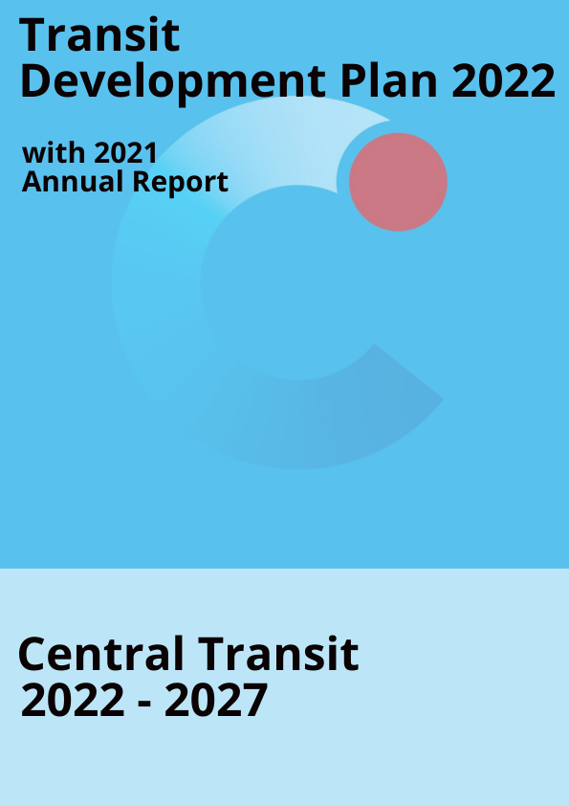
Date of Public Hearings:
July 20, 2022 – August 15, 2022.
Adopted: August 15, 2022
Americans with Disabilities Act (ADA) Information: This material can be made available in an alternate format by emailing the Office of Equal Opportunity at wsdot.wa.gov or by calling toll free, 855-362-4ADA(4232). Persons who have a hearing impairment may make a request by calling the Washington State Relay at 711.
Title VI Notice to Public: It is the Washington State Department of Transportation’s (WSDOT) policy to assure that no person shall, on the grounds of race, color, national origin or sex, as provided by Title VI of the Civil Rights Act of 1964, be excluded from participation in, be denied the benefits of, or be otherwise discriminated against under any of its programs and activities. Any person who believes his/her Title VI protection has been violated, may file a complaint with WSDOT’s Office of Equal Opportunity (OEO). For additional information regarding Title VI complaint procedures and/or information regarding our non-discrimination obligations, please contact OEO’s Title VI Coordinator at 360-705-7090.
This document is submitted per the requirements of RCW 35.58.2795.

Table of Contents
Plan Adoption, Public Hearing and Distribution 4
Public Adoption 4
Public Participation Process 4
Public Distribution 5
Description of Service Area, Operations and Facilities 6
Service Area 6
Operations 6
Exhibit A: Central Transit Connections 7
Exhibit B: Paratransit Service 8
Exhibit C: Full Service Map 10
Exhibit D-G: Individual Service Maps 11
Fares and Facilities 15
Exhibit H-I: Facilities 15
Organization 16
Exhibit J: Organization Chart 16
State and Agency Goals, Objectives and Strategies 17
Table 1 Goals, Objective, Strategies and Alignment with State Goals 18
Table 2 Local Performance Measurements and Targets 21
Plan Consistency 21
Planned Capital Expenses 22
Table 3 2022-2027 Summary of Planned Capital Expenses 22
Planned Operating Expenses 23
Table 4 2022-2027 Summary of Planned Operating Projects 23
Multiyear Financial Plan 24
Tables 5 | 6 Capital and Operating Financial Plans 24
2021 Annual Report 26

Plan Adoption, Public Hearing and Distribution DiDistribution

Plan Adoption
The City of Ellensburg City Council adopted the 2022 - 2027 Transit Development Plan on August 15, 2022 at 7:00 PM at the City of Ellensburg City Council Chambers, 501 N Anderson Street, Ellensburg, WA 98926.
Public Participation Process
The 2022 – 2027 Transit Development Plan was reviewed by the Public Advisory Committee on July 19, 2022 and recommended it be submitted to the Ellensburg City Council for approval.
Public Comment Period: July 20, 2022– August 15, 2022
Comments Submitted to: transit@ci.ellensburg.wa.us
Central Transit
Betsy Dunbar, Transit Manager
501 N Anderson Street
Ellensburg, WA 98926
Public Hearing: The City of Ellensburg will hold a public hearing on the Transit Development Plan on August 15, 2022 at 7:00 PM at the City of Ellensburg City Hall.
Notice Posed to Website: Central Transit posted a notice of the hearing on the Transit Development Plan to its website at www.centraltransit.org on July 20th, 2022.
Notice Published in Local Paper: The Daily Record published a notice of the hearing on the Transit Development Plan on July 27, 2022.
Request for Paper or Digital Copies: Central Transit allowed the public to request a paper or digital copy of the Transit Development Plan on and after July 20, 2022 by emailing transit@ci.ellensburg.wa.us or by calling 509-925-8680.
Available to the Public for Review: Central Transit allow the public to view a copy of the draft Transit Development Plan at City Hall, 501 N Anderson Street, Ellensburg, WA 98926.

Plan Distribution
On August 17, 2022 Central Transit distributed the adopted Transit Development Plan to:
WebGrants at wsdot.ptd.webgrantscloud.com
All cities, counties and regional transportation planning organizations within which Central Transit operates.

Description of Service Area, Operations and Facilities
Service Area
Central Transit is a rural public transit system serving a population of 19,530 residents within a total area of 7.65 square miles. Located just east of the Cascade Range at the junction of Interstate 90 and 82, Ellensburg is known as the most centrally located city in the state of Washington.
Central Transit serves the general public throughout the city limits of Ellensburg.
Schedules and maps can be found on Central Transit’s website at:
http://www.centraltransit.org
Operations
Central Transit provides accessible fixed route and complimentary ADA paratransit services.
Central Transit operates 5 fixed routes daily from 7:00 AM to 8:00 PM. Central Transit’s system maps Exhibit’s C - G, Pages 10 - 14 show the locations of each route, the direction of bus movement, scheduled bus stops, on demand bus stops, bus shelters and transfer service points.
- Routes 12 A and 12 B operate from 7:00 AM to 8:00 PM and serve the north end of the City, Central Washington University, downtown, and the business and shopping areas on the south end of town.
- Route 13 operates from 7:00 AM to 7:00 PM and extends north to Elmview and south to senior housing and the hospital.
- Route 14 operates from 7:00 AM to 7:00 PM and serves additional north end housing and Ellensburg High School on the south end.
- Routes 15 and 16 operates from 7:00 AM to 7:00 PM and serves downtown and the west side of Ellensburg.
The majority of Central Transit’s transfer locations allow connections to other ground transportation which include the Kittitas County Connector, Greyhound, Flixbus, the Yakima-Ellensburg Commuter, the Travel Washington Apple Line, and the Bellair Airporter Shuttle which connects with SeaTac International Airport and Amtrak.

Exhibit A: Central Transit Connections
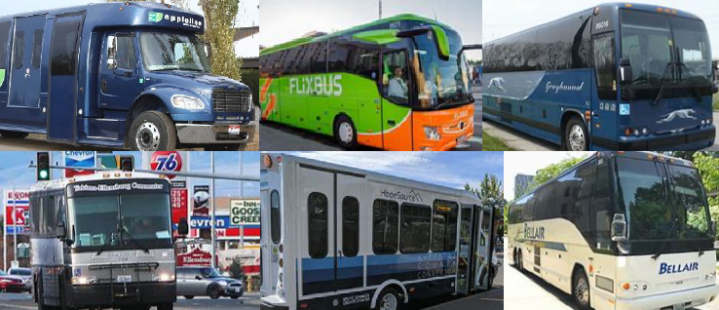
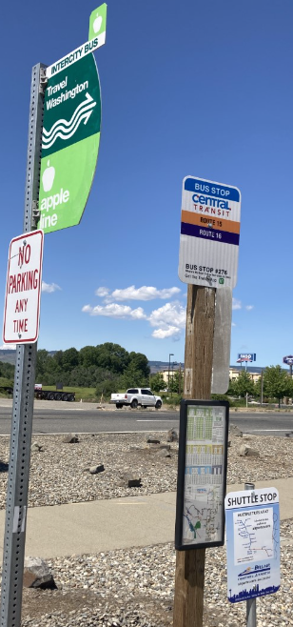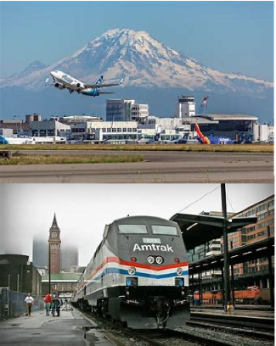

Central Transit also connects passengers with many shared-use biking and walking trails including the Palouse to Cascades State Park Trail.
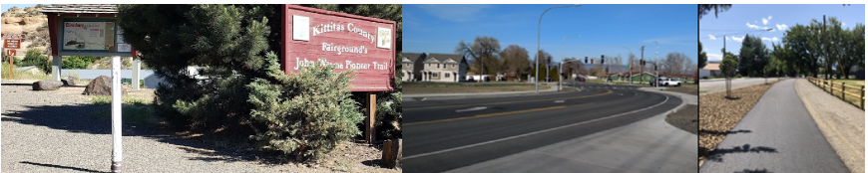

ADA Paratransit services are available within ¾ miles of the fixed route service during the same time as the Central Transit fixed route services.
EXHIBIT B: ADA Paratransit Service
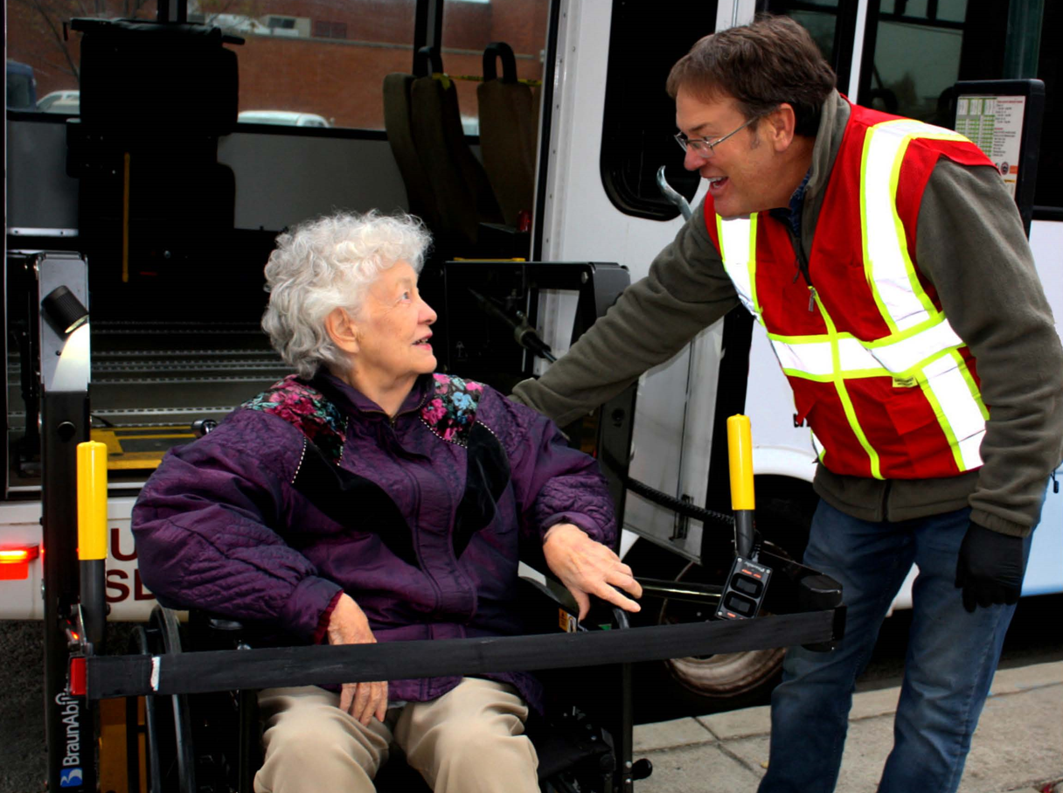

Central Transit’s Cabulance service operates independently 24-7 to provide accessible non-emergency medical transportation for individuals within the City limits of Ellensburg to and from specific medical facilities as initiated by Kittitas Valley Fire and Rescue and other contracted facilities.
Transit services operate year-around with the exception of the following holidays: New Year’s Day, President’s Day, Memorial Day, 4th of July, Thanksgiving Day and Christmas Day.
The City of Ellensburg contracts all transportation operations to HopeSource, a local private nonprofit organization.
The City of Ellensburg provides support for HopeSource’s county wide Dial A Ride and Kittitas County Connector services. The City also provides support for Yakima Transit’s Yakima-Ellensburg Commuter Service.
Route schedules, maps, route planning, alerts, rider guide, news and information can be found on Central Transit’s website at www.centraltransit.org

EXHIBIT C: Full Service Map
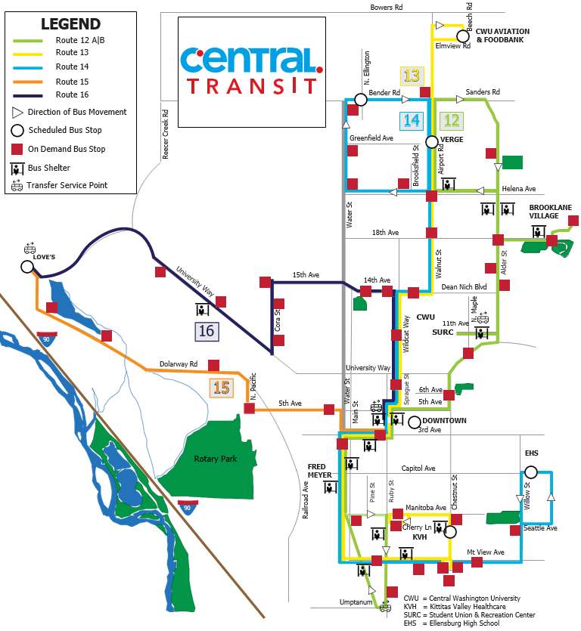
EXHIBIT D: Route 12 A | B Service Map
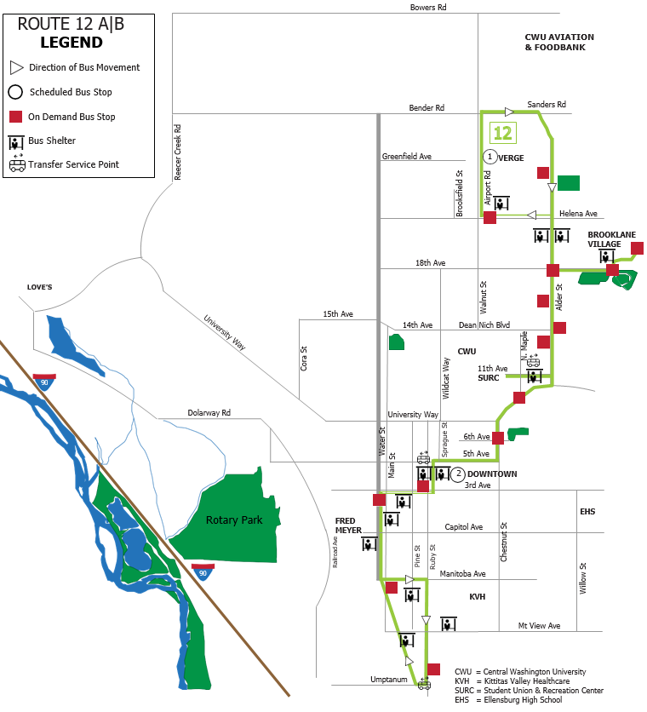
EXHIBIT E: Route 13 Service Map
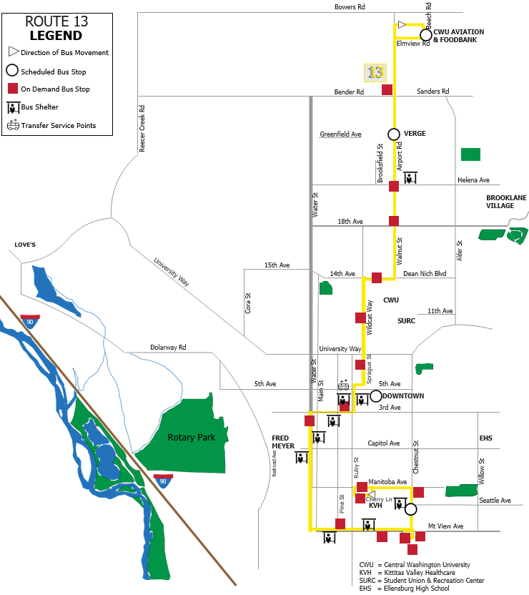
EXHIBIT F: Route 14 Service Map
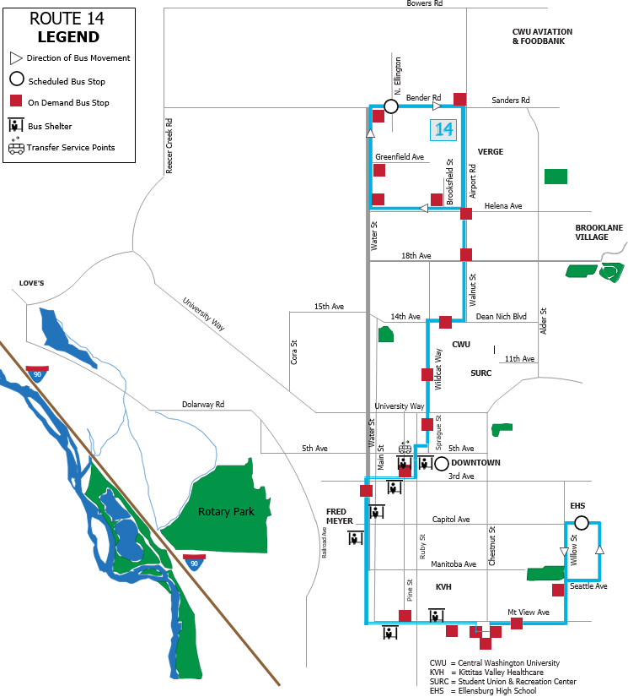
EXHIBIT G: Route 15 | 16 Service Map
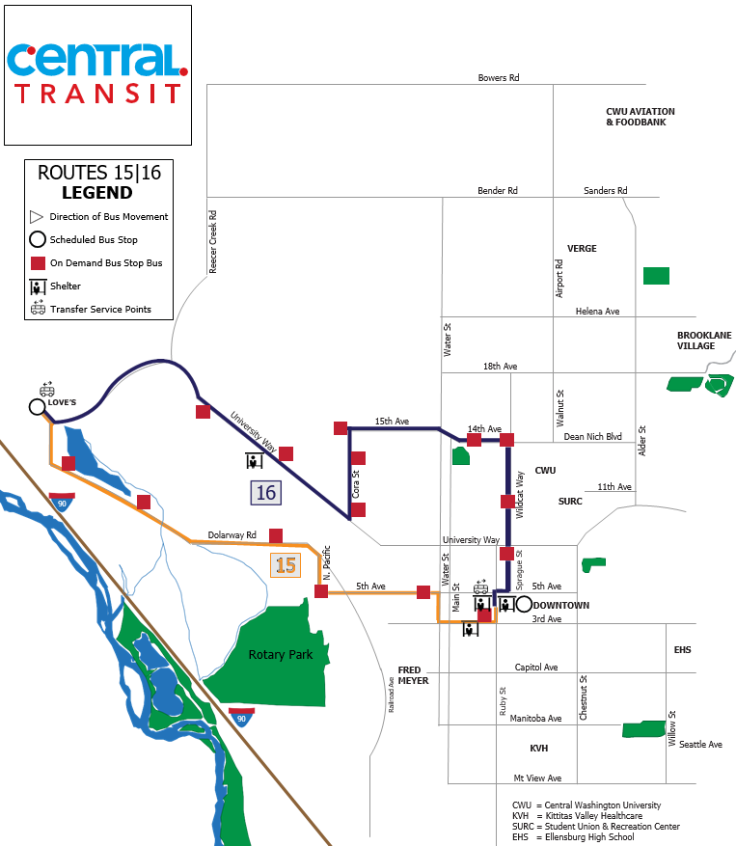
Fares
All Central Transit services are fare free.
Facilities
All operational equipment is owned and maintained by HopeSource located at 700 E. Mountain View, Suite 501, Ellensburg, Washington 98926.
EXHIBIT H: Contractor Facility
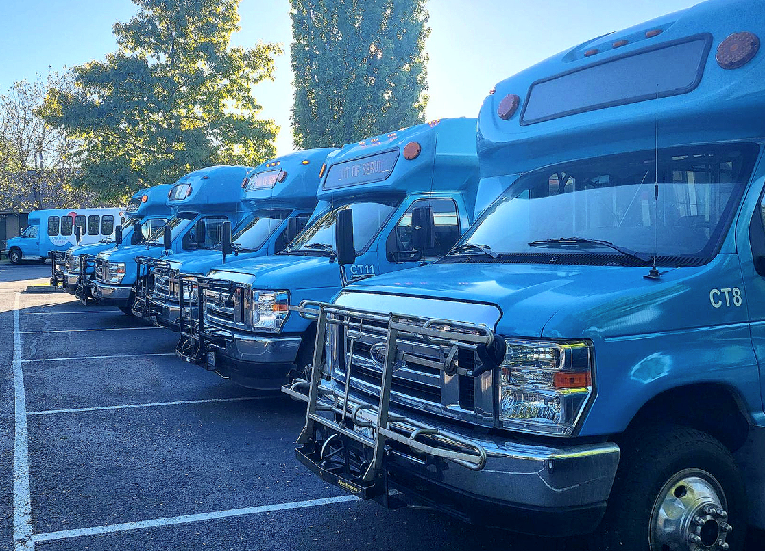

Central Transit’s administrative office is located at 501 N. Anderson Street, Ellensburg, Washington 98926.
EXHIBIT I: City Hall

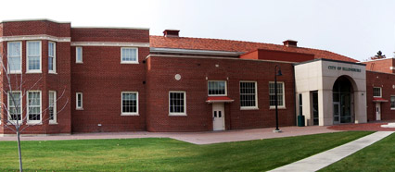

Organization
The Ellensburg City Council is responsible for Central Transit’s operations. The Public Transit Advisory Committee provides oversight of the transit system and reports to the City Council on those and other elements as directed. The City Manager and Public Works and Utilities Director also report to the City Council on Transit activities, policies and finances. The Transit Manager oversees and manages the operational activities of the Transit System.
EXHIBIT J: Organization Chart
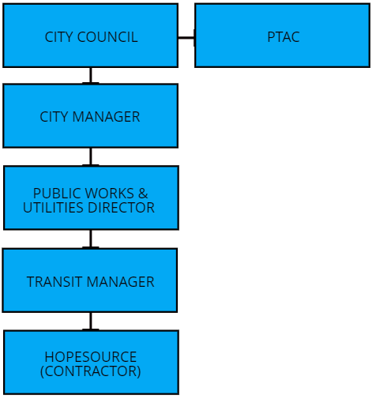

State and Agency Goals, Objectives and Strategies

From 2022-2027, Central Transit will focus on the five key priorities in Table 1 below. The table conveys how Central Transit’s local priorities align with state goals established in the Washington State Transportation Plan.
Central Transit strives to provide safe reliable transportation services connecting passengers to employment, essential services, education and many other services which increases the quality of life in the community. To that end, Central Transit’s proposed project and action strategies align our goals with regional and state’s public transportation objectives.
The state’s six policy goals are:
1. Economic Vitality: To promote and develop transportation systems that stimulate, support and enhance the movement of people and goods to ensure a prosperous economy.
2. Preservation: To maintain, preserve, and extend the life and utility of prior investments in transportation systems and services.
3. Safety: To provide for and improve the safety and security of all passengers and the transportation system.
4. Mobility: To improve the predictable movement of goods and people throughout Washington State.
5. Environment: To enhance Washington’s quality of life through transportation investments that promote energy conservation, enhance healthy communities and protect the environment.
6. Stewardship: To continuously improve the quality, effectiveness, and efficiency of the transportation system.

Table 1: 2022 – 2027 Goals, Objectives, Strategies and Alignment with State Goals
Goals, Objectives and Strategies | Economic Vitality | Preservation | Safety | Mobility | Environment | Stewardship
Goal 1: Improve convenience, reliability and customer service of Transit Services
Objective 1.1: Evaluate current Central Transit reliability and on-time performance.
Strategy 1.1.1: Evaluate current Central Transit fixed route reliability and on-time performance. | X |  |  | X |  | X
Strategy 1.1.2: Use technology to review and adjust schedules to improve on-time performance. | X |  |  | X |  | X
Strategy 1.1.3 Promote website for convenient transit information and data. | X |  |  | X |  | X
Strategy 1.1.4: Promote passenger real time information applications for easy access and reliable transit information. | X |  |  | X |  | X
Strategy 1.1.5: Promote SMS & IVR navigation tools for passengers with special transportation needs. | X | X |  | X |  | X
Strategy 1.1.6: Coordinate with connecting services to ensure timely connections. | X | X |  | X
Objective 1.2: Provide amenities to make riding transit more comfortable and convenient to passengers.
Strategy 1.2.1: Add additional bus shelters and bench seating. | X |  | X | X |  | X
Strategy 1.2.2: Add additional ADA landings and bus turnouts. | X |  | X | X |  | X
Objective 1.3: Improve service accessibility for non-motorized modes.
Strategy 1.3.1: Identify and complete a prioritized list of non-motorized access deficiencies at existing bus stops and bus shelters. | X |  | X | X
Strategy 1.3.2: Provide connecting services to pedestrian and biking trails. | X |  | X | X | X
Goal 2: Improve operational safety and security
Goals, Objectives and Strategies | Economic Vitality | Preservation | Safety | Mobility | Environment | Stewardship
Objective 2.1: Review best practices and industry standards in the area of safety.
Strategy 2.1.1: Update and implement a safety plan which meets the requirements of 49 C.F.R. Part 673. |  | X | X |  |  | X
Strategy 2.1.2: Ensure vehicle operator trainings occur quarterly and vehicle operators are trained to proficiency in operating the accessibility equipment, including wheelchair and passenger securements on board the vehicles. |  |  | X |  |  | X
Strategy 2.1.3: Install additional surveillance cameras at transit facilities. |  |  | X |  |  | X
Strategy 2.1.4: Enforce transit rules and establish a culture of excellent customer service. |  |  | X |  |  | X
Goal 3: Enhance the integration of transit services to support the economy and preserve the environment.
Objective 3.1: Reduce fossil fuel consumption through the consideration of alternative fuel vehicle technology.
Strategy 3.1.1: Acquire a zero-emissions transition plan. |  |  |  |  | X | X
Strategy 3.1.2: Support the procurement of alternative fuel transit vehicles. |  |  |  |  | X | X
Strategy 3.1.3: Support the development of a zero-emissions infrastructure. | X |  |  |  | X | X
Goal 4: Maximize and expand transit services
Objective 4.1: Operate an efficient, cost effective transit system.
Strategy 4.1.1: Maintain internal controls and compliance over public resources. |  | X |  |  |  | X
Goals, Objectives and Strategies | Economic Vitality | Preservation | Safety | Mobility | Environment | Stewardship
Strategy 4.1.2: Plan financially for future operational and capital needs. |  | X |  |  |  | X
Strategy 4.2.3: Provide connections to other transportation services throughout the state. | X | X |  | X | X
Strategy 4.1.4: Strengthen coordination and integration of social services and transportation resources. | X | X |  | X
Strategy 4.1.5: Expand transportation services within the county. | X | X |  | X | X
Objective 4.2: Improve equal access to public transit.
Strategy 4.2.1: Evaluate service coverage and re-route design standards to improve access for low-income, youth, aging adults and persons with limited mobility. Improve and predict the movement of people throughout the city and state with multimodal connections and other accessible modes of transportation. | X | X |  | X | X
Goal 5: Meet the requirements of the Americans with Disabilities.
Objective 5.1 Ensure Central Transit buses and amenities are ADA accessible.
Strategy 5.1.1: Continue to provide ADA Paratransit services for those who qualify. | X | X |  | X |  | X
Strategy 5.1.2: Participate in community events, education and direct and indirect public outreach. | X | X |  | X |  | X

Table 2: 2022 – 2027 Local Performance Measurements and Targets
Performance Measure | Target
Technology Amenities | Provide additional apps and icons on the Central Transit website. Add additional software to track on-time performance and reliability.
Passenger Amenities | Add additional bus shelters at active stop and vulnerable population locations. Add additional turnouts, ADA landings, benches and lighting to create convenient, safe locations for passengers to wait for the bus.
Connectivity | Improve non-motorized access deficiencies at existing bus stops and shelters.
Collisions | Zero Collisions
Alternative Fuels | Acquire a zero-emissions transition plan the end of 2022. Use the plan to support the transition to alternative fuel vehicles with a supportive infrastructure.
Transit Productivity | Fixed Route: Increase passenger count per revenue hour by 10-15%. Paratransit: Increase qualified passenger ridership by 5-20%.
Amenity State of Good Repair | Maintain all transit amenities within a state of good repair.
Service Coverage | Review and adjust routes if needed to ensure demographics in service areas within 0.5 miles of a transit stop serve priority populations.
Growth | Expand or add additional routes in community growth and development areas.
Plan Consistency

Central Transit is a voting member on the 4-County Community Transportation Planning Team and participates in the planning of regional projects, policies and program decisions. Central Transit service information is submitted to the Coordinated Public Transit Human Services Transportation Plan to align with the region’s goals. Planned goals and projects are then submitted to the Regional Transportation Improvement Program for inclusion in the State Transportation Improvement program.
Central Transit continues its own strategic planning process by identifying goals, objectives and work plans. Annually, the work plan is reviewed to develop projects adhering to local, state and federal guidelines.
Central Transit continues to develop its own strategies, goals and work plans. Annually, the work plan is reviewed to develop projects adhering to local, state and federal guidelines.
Central Transit’s services and key priorities outlined in Table 3, are consistent with regional and state goals and policies.
- Work with other agencies and jurisdictions to coordinate a safe, accessible and integrated system of public transportation.
- Encourage citizens, students and businesses to use Central Transit as an alternative to the single-occupant vehicle.
- Support adequate funds for Central Transit services to provide services for persons with special transportation needs.
- Encourage coordination among other transit service providers as well as other modes of transportation services.
Planned Capital Expenses

Table 3 2022-2027 Summary of Planned Capital Expenses
Year | Projects |  | Preservation | Replacement | Expansion | Improvement
Amenities and Infrastructure
2022 |  | Bus shelter artwork at CWU bus stop.  Add additional bus shelters with artwork, bus turnouts, ADA landings, bus stop seating and lighting. | X | X
2023 |  | Additional bus shelters with artwork, bus turnouts, ADA landings, bus stop seating and lighting.  Improve service accessibility with curb cuts, sidewalks and connections to non-motorized pathways and trails.  Support a zero-emissions infrastructure, and an intermodal transit station. | X | X
2024 |  | Additional bus shelters with artwork, bus turnouts, ADA landings, bus stop seating and lighting.  Improve service accessibility with curb cuts, sidewalks and connections to non-motorized pathways and trails.  Support a zero-emissions infrastructure, and an intermodal transit station. | X | X
2025 - 2027 |  | Additional bus shelters with artwork, bus turnouts, ADA landings, bus stop seating and lighting.  Improve service accessibility with curb cuts, sidewalks and connections to non-motorized pathways and trails.  Support a zero-emissions infrastructure, and an intermodal transit station. | X | X

Planned Operating Expenses

Table 4: 2022-2027 Summary of Planned Operating Projects
Years  2022 - 2027 | Projects | Reduction | Expansion | Improvement
Increased safety measures to ensure the safety of vehicle operators and passengers. |  |  | X
Implement transit services in areas with high key priority populations. |  |  | X
Use technology to monitor, analyze and improve route schedules. |  |  | X
Promote Central Transit services. |  |  | X
Provide direct and indirect community outreach. |  |  | X
Adjust routes to service new housing and business developments. |  |  | X
Adjust routes to better serve passengers. |  |  | X
Update schedules and timetable brochure. |  |  | X

Multiyear Financial Plan

2022-2027 Capital Improvement Program and Financial Assumptions
Central Transit’s capital improvement program includes the capital expenses identified in Table 4 above.
Retail sales tax collected in Central Transit’s public transportation benefit area is the primary revenue source. Other funding sources include support from Central Washington State University, state operating grant funding, federal capital funding and other miscellaneous revenues.
Growth in Local Sales Tax revenue throughout the planning period of 2-3 percent in all years based on recent trends.
Minimal growth in formula in federal and state operating grants throughout the planning period is 2-3 percent respectively.
Central Transit will be responsible for any matching funds.
These system projects and improvements noted above are subject to change pending inputs from the City of Ellensburg’s Finance Department, the Public Transit Advisory Committee, and the City Council.

Table 5: 2022-2027 Capital Improvement Financial Plan
Capital Expenditure | 2022 | 2023 | 2024 | 2025 | 2026 | 2027
Bus Stop Seating | 5,000 | 10,000 | 10,000 | 10,000 | 10,000 | 10,000
Bus Shelters | 20,000 | 50,000 | 50,000 | 50,000 | 50,000 | 50,000
Safety | 5,000 | 50,000 | 5,000 | 5,000 | 5,000 | 5,000
Zero-Emissions Transition Plan | 120,000
Infrastructure |  | 200,000 | 125,000 | 50,000 | 50,000 | 50,000
Artwork | 10,000 | 15,000 | 15,000 | 15,000 | 15,000 | 15,000

Capital Revenue | 2022 | 2023 | 2024 | 2025 | 2026 | 2027
Federal
Green Transportation | 120,000
CRRSAA | 629,644
Total | 902,144

Table 6: Operating and Maintenance Financial Plan
Operating Revenue | 2022 | 2023 | 2024 | 2025 | 2026 | 2027
State
PTD0513 WSDOT 2021 - 2023 | 5,604 |  | 2,800 | 2,800 | 2,800 | 2,800
2023 l Special Needs Formula |  | 1,166
2021 ARPA Operating Grant | 142,983
PTD0307 Consolidated Grant 2021 - 2023 | 480,670 | 240,335
Consolidated 2023 -2025 |  | 240,335 | 480,670 | 240,335 | 480,670 | 240,335
WSTIP | 2,500 | 2,500 | 2,500 | 2,500 | 2,500 | 2,500
Transportation Services (ASCWU) | 75,000 | 75,000 | 75,000 | 75,000 | 75,000 | 75,000
Interest Income | 20,000 | 20,000 | 20,000 | 20,000 | 20,000 | 20,000
Operating Revenue | 2022 | 2023 | 2024 | 2025 | 2026 | 2027
Local Sales Tax | 1,356,000 | 1,360,000 | 1,365,000 | 1,370,000 | 1,375,000 | 1,400,000
Total | 2,082,757 | 1,939,336 | 1,945,970 | 1,710,635 | 1,955,970 | 1,740,635

Operating Expenses | 2022 | 2023 | 2024 | 2025 | 2026 | 2027
Administrative | 280,000 | 285,000 | 290,000 | 295,000 | 300,000 | 305,000
Fixed Route | 1,200,000 | 1,300,000 | 1,350,000 | 1,400,000 | 1,450,000 | 1,500,000
Paratransit | 17,000 | 17,500 | 18,000 | 18,500 | 19,000 | 19,500
Cabulance | 42,500 | 43,000 | 43,500 | 44,000 | 44,500 | 45,000
Dial A Ride | 82,000 | 82,500 | 82,500 | 82,500 | 82,500 | 82,500
Kittitas County Connector | 44,000 | 44,000 | 44,000 | 44,000 | 44,000 | 44,000
Yakima-Ellensburg Commuter | 20,000 | 20,000 | 20,000 | 20,000 | 20,000 | 20,000
Total Expenses | 1,685,500 | 1,792,000 | 1,848,000 | 1,904,000 | 1,960,000 | 2,016,000

2021 Annual Report

2021 Revenues and Expenses
Ellensburg Public Transit Revenues thru 12-31-21 | 2021 Total
Retail Sales Tax .02% for Public Transit | 1,358,736
Fed Transit Funding via WSDOT – CARES Act (1st dist.)
Fed Transit Funding via WSDOT – CARES Act (2nd dist.) | 208,194
WSDOT Consolidated Grant – No Federal Money
Special Transportation Needs Grant
WSDOT Consolidated Grant | 110,263
WSDOT CRRSAA
WSDOT- Capital Rural Mobility | 10,366
WSTIP
WSTIP - Risk Management Grants | 2,500
Transportation Services
Interest Income | 11,349
Transit – Misc. Revenue | 75,000
Total Revenues | 1,776,408

Central Transit Public Transit Expenditures thru 12-31-21 | 2021 Total
Total Administrative | 173,800
Fixed Route | 1,187,319
Paratransit | 15,960
Cabulance | 41,818
Yakima Transit | 20,000
Dial A Ride | 81,813
Kittitas County Connector | 43,500
Total Transit | 1,564,210

2021 Central Transit Ridership Stats 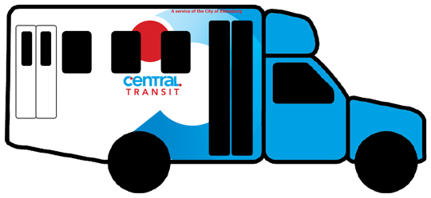
SERVICE | 1-WAY BOARDINGS | REVENUE MILES | REVENUE HOURS | GALLONS OF FUEL | COLLISIONS | INJURIES
Fixed Route | 61,082 | 238,278 | 21,305 | 34,486 | 0 | 0
Paratransit | 338 | 1450 | 307 | 266 | 0 | 0
Cabulance | 126 | 227 | 236 | 41 | 0 | 0
Dial A Ride | 9,072 | 86,238 | 8,466 | 12,902 | 0 | 0
KCC | 4,742 | 94,270 | 4,510 | 9,018 | 0 | 0
Total | 75,360 | 420,463 | 34,824 | 56,713 | 0 | 0

Central Transit | 2021
Transit Data - Fixed Route
City Employees – FTE’s | 1.5
Farebox Revenues | 0
Gasoline Fuel Consumed (gallons) | 34,486
Passenger Trips | 61,082
Revenue Vehicle Hours | 21,305
Revenue Vehicle Miles | 238,278
Total Vehicle Hours | 22,254
Total Vehicle Miles | 246,099
Transit Data - Demand Response Paratransit
City Employees – FTE’s | 1.5
Gasoline Fuel Consumed (gallons) | 266
Operating Expenses | 15,960
Passenger Trips | 388
Revenue Vehicle Hours | 307
Revenue Vehicle Miles | 1450
Total Vehicle Hours | 343
Total Vehicle Miles | 1610
Revenue - Local Operating
Sales Tax | 1,358,736
Revenue - State Operating
Other State Operating Grants | 0
Sales Tax Equalization | 0
State Operating Distribution | 0
State Regional Mobility Operating Grants | 0
State Rural Mobility Operating Grants | 0
State Special Needs Operating Grants | 0
Revenue - State Capital
Other State Capital Funds | 0
Sales Tax Equalization - Capital | 0
State Regional Mobility Grants | 0
State Rural Mobility Grants | 10,366
State Special Needs Grants | 0
Revenue - Federal Operating
Capital Assistance Spent on Operations (§5317) | 0
CARES Act Rural Area Program Funds (§5311) | 208,194
Federal Section §5307 Operating | 0
Federal Section §5307 Preventative | 0
Federal Section §5311 Operating | 110,263
FTA §5310 Capital Assistance Spent on Operations | 0
FTA §5310 Special Needs of Elderly Individuals and Individuals with Disabilities Formula Program Funds | 0
Revenue - Other Operating
Other-Advertising | 0
Other-Gain (Loss) on Sale of Assets | 0
Other-Interest | 11,349
Other-MISC | 75,000
Revenue - Other Capital
Land Bank Agreement & Credits | 0
Expenses - Expenses
Debt service - Interest | 0
Debt service - Principal | 0
Depreciation (Not included in Total Expenditures) | 0
Local Capital Funds | 0
Other - Expenditures | 0
Fund Balances - Ending Fund Balances
Capital Reserve Funds | 0
Contingency Reserve | 0
Debt Service Funds | 0
General Fund | 540,968
Insurance Funds | 0
Operating Reserve | 1,585,266
Other Balance | 0
Unrestricted Cash and Investments | 456,896
Working Capital | 0

2021 Transportation Improvements
ADA curb cuts and ramp upgrades.
Sidewalk repairs and improvements.
Bus shelter artwork installed.
Updated Central Transit logo.
Updated bus wraps.
New bus stop signs with SMS & IVR services.
New interactive Central Transit website.
Live Central Transit operations dashboard and GPS playback.
TRANSIT application linked to Google Maps.
Service Alerts for TRANSIT app and Google Maps.
Additional ADA landings.

